**Unit 03 Wine Sales Project**

Predict 411 Section 59

Winter 2016

Joshua Peng

Joshua Peng

Unit 03 Wine Sales Project

Hyperlinks

Introduction

1. Data Exploration

2. Data Preparation

3. Build Models

4. Select Models

5. Model Deployment

6. Bonus

7. Conclusion

8. References

**Bonus:** For the bonus section, I am attempting to gain +30 points. I built 2 models (+10 for both models), interpreted the parameter coefficients, and compared them to my best model (model 6) in section 4. Select Models based on Goodness of Fit criteria, sum of absolute error, and sum of squared error over the first 30 observations.

1. I built a model using PROC GENMOD with a Zero Inflated Poisson distribution (zeromodel using complementary log-log link) with STARS0 and LabelAppeal as categorical variables.

2. I built a model using PROC GENMOD with a Zero Inflated Poisson distribution (zeromodel using probit link) with STARS0 and LabelAppeal as categorical variables.

3. As presented in the recorded session, we can gain +10 bonus points by confirming that using the output file from PROC GENMOD with PROC PLM will generate the same predicted values as with a SAS data step for a Zero Inflated Poisson Model (ZIP model) which are composed of 2 separate model processes.

# Introduction

The wine data set contains 12,795 observations each of which represent information on 12,795 commercially available wines. There are 12 continuous variables related to the chemical properties of the wine being sold. There are 2 numerical variables for the marketing score based on the visual appeal of the label and wine rating based on number of stars. The target variable is the number of sample cases of wine that were purchased by wine distribution companies after sampling a wine. These cases would be used to provide tasting samples to restaurants and wine stores around the United States. The more sample cases purchased, the more likely a wine is to be sold at a high end restaurant.

A large wine manufacturer is studying the data in order to predict the number of wine cases ordered based upon the wine characteristics. If it is possible to predict the number of cases, the wine manufacturer will be able to adjust their wine offerings with the goal to maximize sales. The purpose of this project is to build a model to predict the number of cases of wine that will be sold given certain properties of the wine. I will specifically work towards building Poisson and Negative Binomial models that will predict the target number of cases ordered for each wine.

# 1. Data Exploration

The Data Dictionary provided details the 14 variables related to the characteristics of the wine. The variables can be segmented into 2 groups: 12 continuous variables related to the chemical properties of the wine and 2 numerical variables related to the subjective perception of the wine. The variable, LabelAppeal, is the Marketing Score which indicates the visual appeal of the label design where high numbers suggest customers like the design and low numbers suggest customers do not like the design. The variable, STARS, is the wine rating by a team of experts between 1 to 4 stars (4 Stars = Excellent, 1 Star = Poor). STARS is a clear indication of the wine’s popularity which should have a strong positive relationship with the number of cases.

|  |  |  |
| --- | --- | --- |
| **Variable** | **Definition** | **Theoretical Effect** |
| TARGET | Number of Cases Purchased | None |
|  |  |  |
| AcidIndex | Proprietary method of testing total acidity of wine by using a weighted average |  |
| Alcohol | Alcohol Content |  |
| Chlorides | Chloride content of wine |  |
| CitricAcid | Citric Acid Content |  |
| Density | Density of Wine |  |
| FixedAcidity | Fixed Acidity of Wine |  |
| FreeSulfurDioxide | Sulfur Dioxide content of wine |  |
| LabelAppeal | Marketing Score indicating the appeal of label design for consumers. High numbers suggest customers like the label design. Negative numbers suggest customers don't like the design. | Many consumers purchase based on the visual appeal of the wine label design. Higher numbers suggest better sales. |
| ResidualSugar | Residual Sugar of wine |  |
| STARS | Wine rating by a team of experts. 4 Stars = Excellent, 1 Star = Poor | A high number of stars suggests high sales. |
| Sulphates | Sulfate content of wine |  |
| TotalSulfurDioxide | Total Sulfur Dioxide of Wine |  |
| VolatileAcidity | Volatile Acid content of wine |  |
| pH | pH of wine |  |

Next, I use PROC MEANS to examine the descriptive statistics of the variables and open the wine data set to look at the first few rows of observations. The LabelAppeal marketing score is on a -2 to +2 scale and STARS wine rating is on a 1 to 4 scale. Since these variables take on a few possible values within a very small range, I may be able to use these two variables as categorical variables.

**Addressing missing observations**

I also notice that many variables have missing observations in the data set, most notably STARS with the most at 3359. For the continuous variables, I will impute the missing values with the mean value. For STARS, which I will also use as a categorical variable, I rounded the mean value to the nearest integer and created a binary indicator variable to flag when the data is missing. I will also try LabelAppeal as a categorical variable and see if that improves model performance.

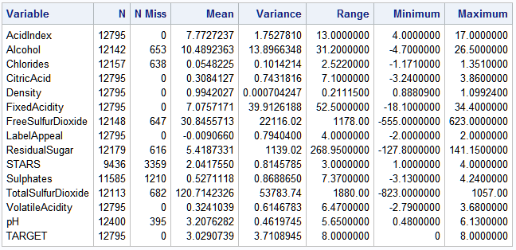

In the later stages of the project when I am selecting variables to include in the model, if I decide to include a variable that originally had missing values, I will consider bringing along with it the corresponding indicator variable because the missing observations make up a large portion of the data.

I want to contain information from the missing observations along with the original values of STARS together. I will create a new variable, STARS0, by replicating STARS and setting the missing values to 0 so that the range will be between 0 to 4. As a categorical variable, the “0” class will not signify the lowest wine rating, because the classes are not treated as ordered. However, as a continuous variable, the “0” class will indicate a very bad wine and perhaps this variable may turn out to be a better predictor than the original STARS.

**Quick look at box plots**

A quick glance at some box plots for Alcohol, Chlorides, FreeSulfurDioxide, ResidualSugar, Sulphates, TotalSulfurDioxide, and pH confirm and highlight the glaring problem that these variables have impossible negative values.

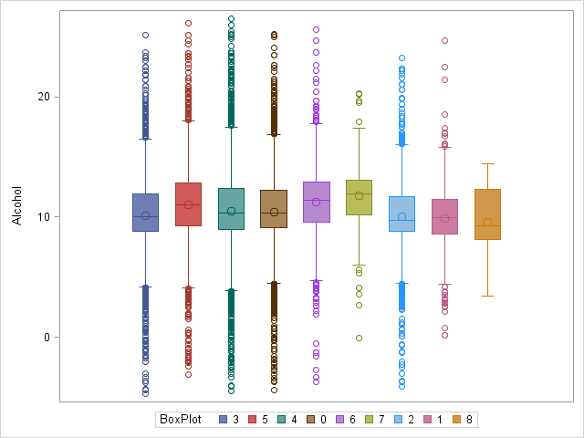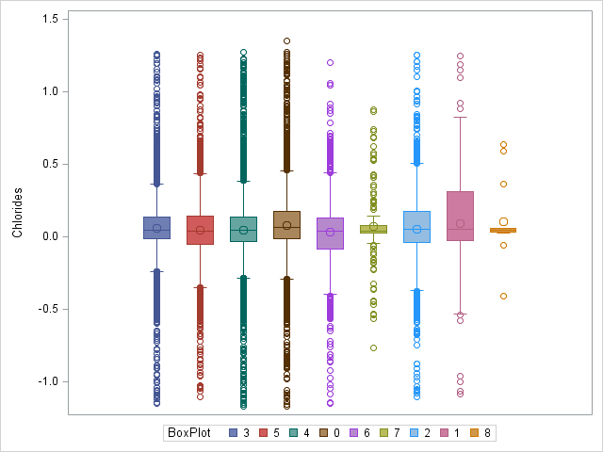

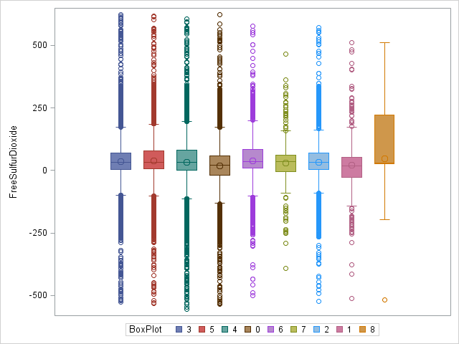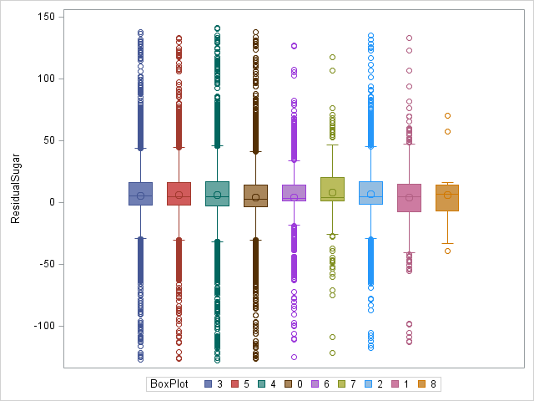

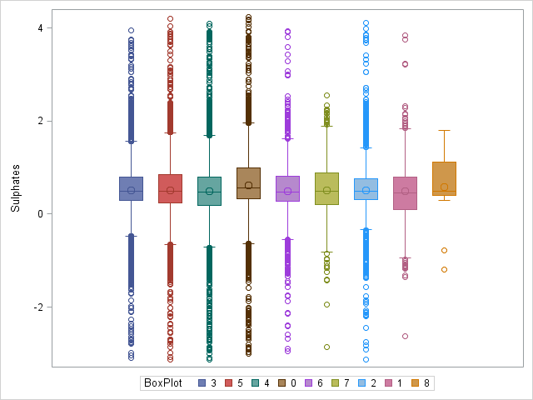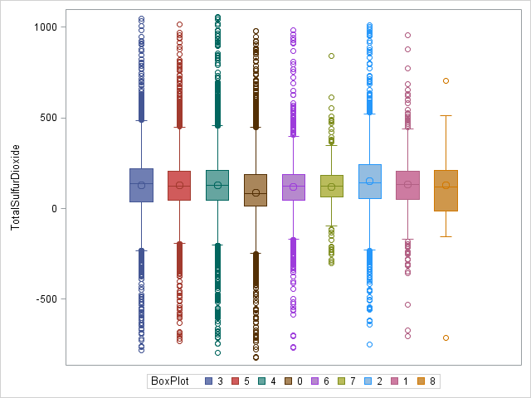

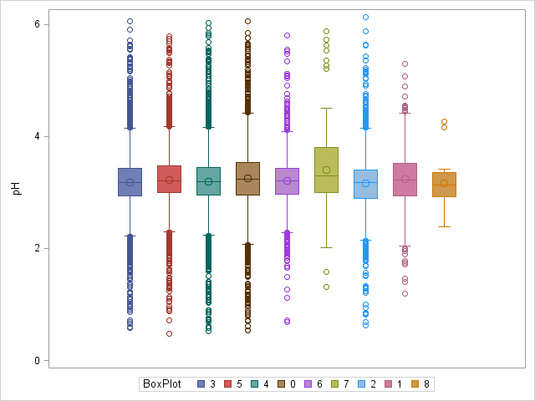

**Addressing negative values and adding new variables**

Many of the variables have negative values which do not make sense because they are count variables and measure a frequency, amount, or concentration of a particular substance which can only take on positive values, including: Alcohol, Chlorides, CitricAcid, FixedAcidity, FreeSulfurDioxide, ResidualSugar, Sulphates, TotalSulfurDioxide, and VolatileAcidity. The variable distributions may have been shifted downward by adding a negative constant. I will add the absolute value of the minimum negative value to all of the observations of variables with negative values to make sure the whole distribution is positive with a minimum value of 0. These new “reshifted” variables will have the prefix “rs_”. There may have been a recording error such that several observations were mistakenly recorded as negative. For this case, I will take the absolute value of these variables with negative values to make sure all of the observations are positive. These new absolute value transformed variables will have the prefix “av_”.

As I will discuss later when I examine the relationship of each variable with wine quality, I can derive new variables from existing variables that relate to wine quality and taste. Fixed acidity is measured as total acidity minus volatile acidity. Therefore, I can derive TotalAcidity by adding together FixedAcidity and VolatileAcidity.

Only a proportion of the sulfur dioxide added to a wine will be effective as an anti-oxidant. The rest will combine with other elements in the wine and cease to be useful. The part lost into the wine is said to be bound, the active part to be free. Therefore, I derive a new variable, BoundSulfurDioxide, from TotalSulfurDioxide and FreeSulfurDioxide by taking the difference between them.

It appears that the missing observations of TotalSulfurDioxide and FreeSulfurDioxide do not overlap as there are almost double the amount of missing observations for BoundSulfurDioxide. Additionally, the missing observations of FixedAcidity and VolatileAcidity do no overlap as well, as there are almost double the amount of missing observations for TotalAcidity. To address this discrepancy, I will derive another form of BoundSulfurDioxide called BoundSulfurDioxide2 that is computed after the missing values from TotalSulfurDioxide and FreeSulfurDioxide have been imputed with their mean values.

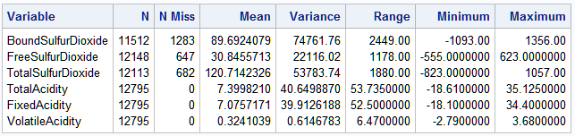

New BoundSulfurDioxide Variables added:

* BoundSulfurDioxide = TotalSulfurDioxide - FreeSulfurDioxide
  + with its missing values replaced by its mean value
* BoundSulfurDioxide2 = TotalSulfurDioxide - FreeSulfurDioxide
  + after the missing values from TotalSulfurDioxide and FreeSulfurDioxide have had their missing values imputed with their mean values
* rs_BoundSulfurDioxide = abs(rs_TotalSulfurDioxide – rs_FreeSulfurDioxide)
* rs_BoundSulfurDioxide2 = BoundSulfurDioxide + abs(min(BoundSulfurDioxide))
* av_BoundSulfurDioxide = abs(abs(TotalSulfurDioxide) – abs(FreeSulfurDioxide))
* av_BoundSulfurDioxide2 = abs(BoundSulfurDioxide2)

Fortunately, there are no missing values in FixedAcidity or VolatileAcidity, however there are still negative values. To address this case, I derive other forms of TotalAcidity that are computed before FixedAcidity and VolatileAcidity have been adjusted for negative values through reshifting or absolute value transformations.

New TotalAcidity variables added:

* TotalAcidity = FixedAcidity + VolatileAcidity
* rs_TotalAcidity = abs(rs_FixedAcidity + rs_VolatileAcidity)
* rs_TotalAcidity2 = TotalAcidity + abs(min(TotalAcidity))
* av_TotalAcidity = abs(abs(FixedAcidity) + abs(VolatileAcidity))
* av_TotalAcidity2 = abs(TotalAcidity)

**Examining TARGET**

Next, I examine the mean and variance of the TARGET variable which measures the number of cases purchased. The assumption that the mean (3.0290739) and variance (3.7108945) are equal for the Poisson distribution is violated, although the values are rather close in value. However, the assumption that the variation should be larger than the mean for the Negative Binomial distribution is satisfied which means that TARGET exemplifies overdispersion.

|  |  |
| --- | --- |
| **TARGET** | |
| **Mean** | **Variance** |
| 3.0290739 | 3.7108945 |

I examine the histogram of TARGET and find that the shape is zero inflated but otherwise resembles a normal distribution taking values between 0 to 8 with a central peak at 4. Although I would normally restrict my modeling approach based on the zero inflation present in TARGET, for the purposes of this assignment, I will build OLS regression, Poisson, and Negative Binomial models and examine the differences in performance.

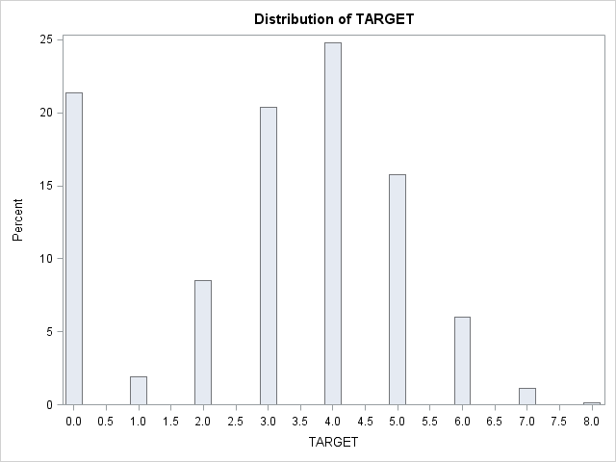

**Examining histograms and exploring the relationship of variables with wine quality**

In the following section, I will not post the histogram of the reshifted transformed variables as the shape of the distribution will be exactly the same. The values of the reshifted variables are just shifted upward by a constant. The histogram of the original variable with imputed mean values will be on the left and the histogram of the absolute value transformed variable will be on the right.

**Sulphates = Sulfites and av_Sulfites**

I believe this variable is incorrectly named and should actually be “Sulfites” instead of “Sulphates.” Sulfur dioxide (SO2) is added at several points in the process of conventional vinification and is present in the finished wine in the form of sulphites (or sulfites if you are American). Sulfites are sulfur compounds that have a relationship with wine, but sulfate, a salt of sulfuric acid, is not. Sulfates are simple inorganic chemical compounds of sulfur which are not meant for consumption and play no role in the wine making process. Although there exist some approved sulfate additives for wine, there is abundantly more information about sulfites in wine. I will assume that the wine manufacturer that organized the data set intended to use “Sulfites” and will rename the variable accordingly. From this point on, I will refer to the variable “Sulphates” as “Sulfites.”

All wines contain sulfur dioxide in various forms, collectively known as sulfites. Sulfur dioxide (SO2 for short) is by far the most important additive used in wine. Even in completely unsulfured wine it is present at concentrations of up to 10 milligrams per liter. Commercially-made wines contain from 10 to 20 times that amount. Its value derives from its ability to perform several critical functions such as preserving a wine’s freshness and fruit character by virtue of anti-oxidative, anti-microbial and anti-enzymatic properties. Oxidation is the reaction of wine with oxygen. It can alter its color and odor, tending to make wines darker and dryer, and is often dismissed as a fault. Excessive oxidation does ruin wine. But controlled oxidization can add complexity, and is crucial to certain styles. Sulfur dioxide drastically inhibits the process of oxidation. playing an important part of the aging process. The judicious use of SO2 is required to make high-quality, shelf-stable wine.

There are four points at which SO2 is commonly used in conventional winemaking. It is applied in the form of metabisulfite to inhibit the action of wild yeasts and prevent oxidation during grape picking. So that the grapes can be preserved and not be rushed to the winery. It is added during grape crushing to prevent fermentation from beginning with wild yeasts before cultured yeasts can be added. Cultured yeasts are bred to be more resistant to SO2. It is added at any point during fermentation, but most commonly at the end to stop or prevent malolactic fermentation. A natural winemaker has to wait for this process to finish naturally. Lastly, it is added to prevent oxidation (or any other microbial action) in the bottled wine. In sweet wines there is the danger that fermentation will restart. A natural winemaker would only ever use SO2 at bottling, only in white wines, and only in very small quantities. Many natural winemakers use none at all.1

There are three main reasons you might not want sulfites added to your wine. Sulfites can cause potentially fatal allergic reactions and has been linked with numerous other health problems, including hangovers. Sulfite is an artificial ingredient and upon adding it to a wine, the winemaker can no longer claim that the wine is “natural.” Sulfites have an unpleasant smell, like that of a struck match, and is detectable by your tongue at very low concentrations. Most people can detect sulfur dioxide in water at around 11 mg/l. In wine, the presence of alcohol and acids means that it is less obvious. For an experienced taster, accustomed to natural wine, SO2 becomes unpleasant at concentrations of around 20-30 mg/l, depending on the style of wine and the ratio of free to bound SO2. For most people the threshold is much higher, but most people have never tasted an unsulfured wine. They may well be able to taste the SO2, but are not accustomed to the taste.

The shape of the Sulfites histogram resembles a plateau with low kurtosis except there is a large central spike at the mean value of 0.5271118 which is accentuated with imputed mean values. The av_Sulfites histogram is positively skewed with a long right tail. The Kolmogorov-Smirnov test for normality for both histograms results in a significant p-value (p < 0.01) which suggests that the data does not follow a normal distribution.

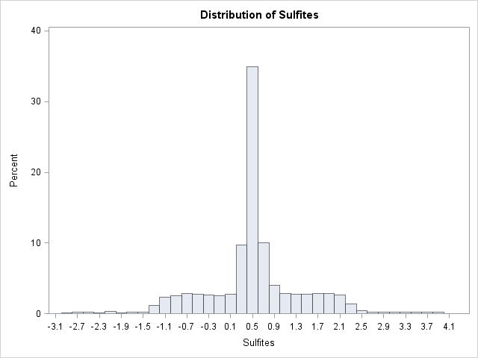 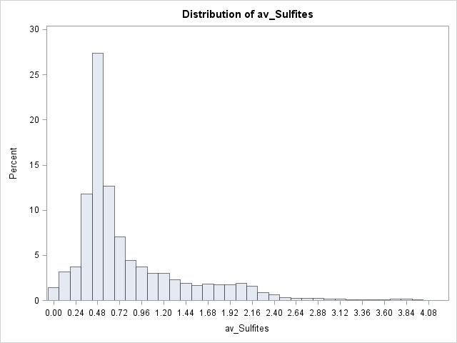

**TotalSulfurDioxide and av_TotalSulfurDioxide**

SO2 is a gas at room temperature. But when SO2 is free in wine, it can take 3 different forms:

* molecular SO2 when in solution with water (H2O)
* bisulfite when it is a HSO3– ion
* sulfite when it is a SO32- ion

Total SO2 = free SO2 + bound SO2

* free SO2: molecular SO2 + bisulfites + sulfites
* bound SO2: sulfites attached to either sugars, acetaldehyde or phenolic compounds

The free SO2 portion (not associated with wine molecules) is effectively the buffer against microbes and oxidation. Whereas the bound SO2 portion, which is associated with wine molecules, is the part which has already done its work and cannot be useful any longer in this context. Total SO2 should be kept below 110 ppm for table wines because, at higher levels, the wine can acquire off-flavors. For dessert and fortified wines that are very sweet, it may be necessary to exceed this limit to obtain adequate free SO2. The higher the level of total SO2 in the wine, the higher the ratio will be, because there are fewer unbound compounds available for reacting with additional sulfur dioxide as it is added. Sulfur dioxide is also more effective if it is added less often and in greater quantities because it will be more of a shock to the microbes.2

The shape of the TotalSulfurDioxide histogram resembles a plateau with low kurtosis except there is a large central spike at the mean value of 120.7142326 which is accentuated with imputed mean values. The av_TotalSulfurDioxide histogram is positively skewed with a large peak at the mean. The Kolmogorov-Smirnov test for normality for both histograms results in a significant p-value (p < 0.01) which suggests that the data does not follow a normal distribution.

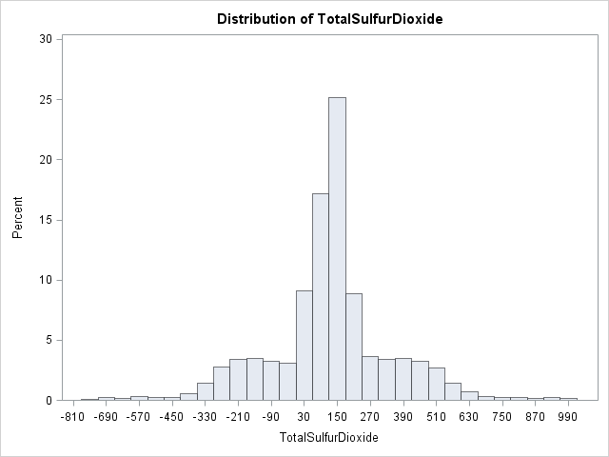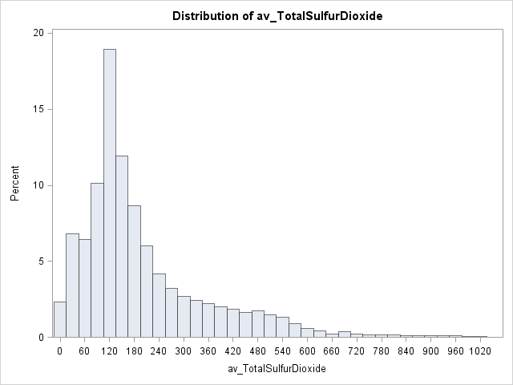

**FreeSulfurDioxide and av_FreeSulfurDioxide**

The shape of the FreeSulfurDioxide histogram resembles a plateau with low kurtosis except there is a large central spike at the mean value of 30.8455713 which is accentuated with imputed mean values. The av_FreeSulfurDioxide histogram is highly positively skewed with practically no left half/tail of the curve. The Kolmogorov-Smirnov test for normality for both histograms results in a significant p-value (p < 0.01) which suggests that the data does not follow a normal distribution.

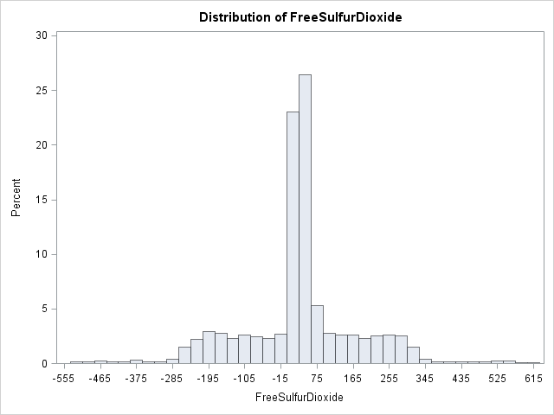 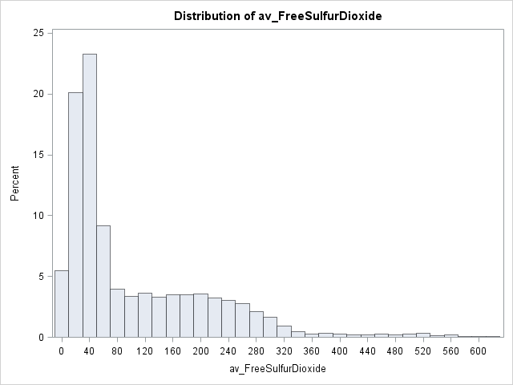

The amount of SO2 added to wine depends on the type of wine, the sensitivity of the taster, and the ratio between free and bound sulfur dioxide in the wine. Only a proportion of the SO2 added to a wine will be effective as an anti-oxidant. The rest will combine with other elements in the wine and cease to be useful. The part lost into the wine is said to be bound, the active part to be free. A good winemaker will try to get the highest proportion of free SO2 to bound that he can. At best, this will be about half the amount bound.

**BoundSulfurDioxide and av_BoundSulfurDioxide**

For white wines, a level of 0.8 ppm molecular SO2 will slow down the growth of yeast and will prevent the growth of most other microbes. This level of sulfur dioxide will bind up most of the acetaldehyde in a wine and reduce any oxidation aroma considerably. Therefore, 0.8 ppm is a good target level for molecular SO2 immediately prior to bottling and will provide the maximum protection for the finished wine. However, sensitive tasters will be able to detect a slight burnt match aroma at 0.8 ppm SO2. This is usually not a problem however because few consumers will be able to detect it. Additionally, if the wine is bottle-aged for a few months before consumption, the SO2 will decrease as more sulfites react with other chemical constituents in the wine and become bound. Thus, a wine bottled at 0.8 ppm will decrease to a lower level fairly quickly and there would be no detectable sulfur dioxide aroma.

The shape of the BoundSulfurDioxide histogram resembles a normal distribution with low kurtosis except there is a large central spike at the mean value of 89.6924079 which is accentuated with imputed mean values. The av_BoundSulfurDioxide histogram is highly kurtotic and positively skewed with a long right tail. The Kolmogorov-Smirnov test for normality for both histograms results in a significant p-value (p < 0.01) which suggests that the data does not follow a normal distribution.

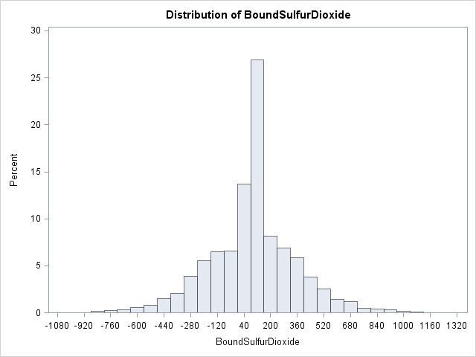 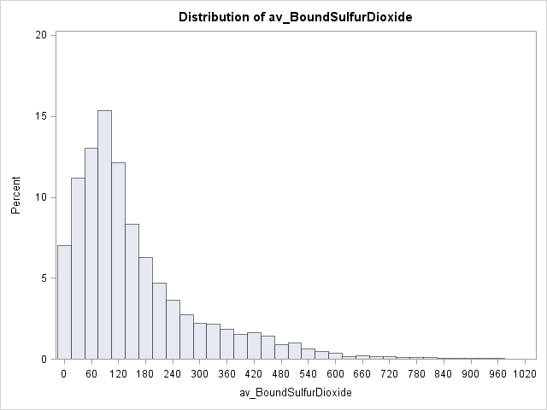

**BoundSulfurDioxide2 and av_BoundSulfurDioxide2**

The shape of the BoundSulfurDioxide2 histogram is similar to that of BoundSulfurDioxide resembling a normal distribution with low kurtosis except there is a large central spike at the mean value of 89.86866 which is accentuated with imputed mean values. The av_BoundSulfurDioxide2 histogram is positively skewed with a large spike at the mean with a long right tail. The Kolmogorov-Smirnov test for normality for both histograms results in a significant p-value (p < 0.01) which suggests that the data does not follow a normal distribution.

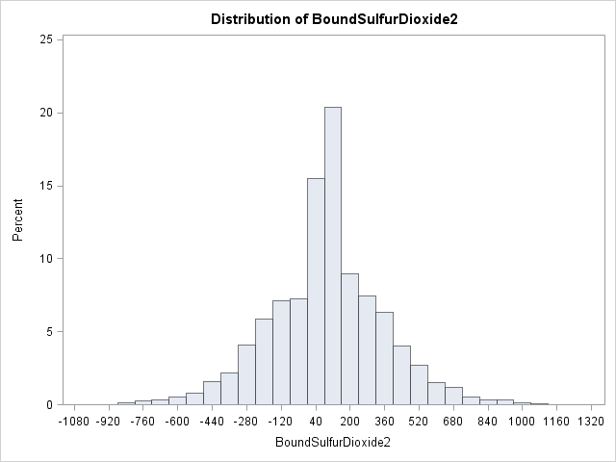 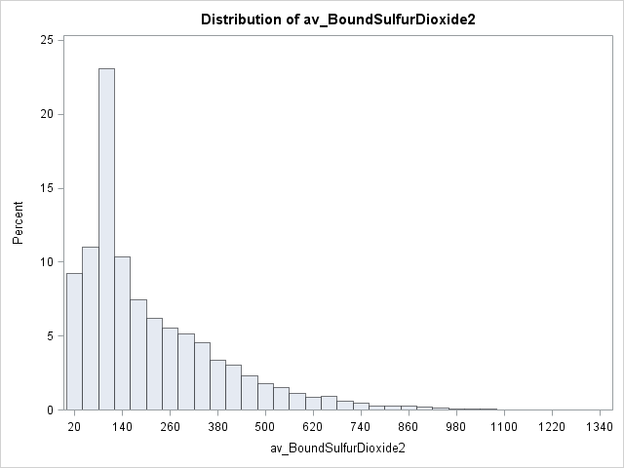

**ResidualSugar and av_ResidualSugar**

Residual sugar refers to any natural grape sugars that are left over after fermentation ceases whether on purpose or not. The juice of wine grapes starts out intensely sweet, and fermentation uses up that sugar as the yeasts feast upon it generating the by-products of CO2 gas and alcohol. Fermentation may stop due to alcohol toxicity. Different yeast strains can tolerate different levels of alcohol, so a weaker strain might die before eating all the sugar in the fermenting wine. In the case of a dessert wine, the sugars are concentrated when the grapes get shriveled, so there's a lot of sugar to ferment. When alcohol reaches the level of a normal dry wine, say 12 or 14%, the yeast might die, but plenty of uneaten sugar is left. In the case of a fortified wine, hard liquor is added to get a similar job done. Fermentation is also temperature-sensitive, happening faster at warm temperatures and slower in the cold, so it will stop if the temperature drops too much. A winemaker can chill a wine down until fermentation stops, then just get rid of the yeast.3

In addition to its obvious sweetening power, sugar also has a bonus effect: it can help wines age well. Wines with a little residual sugar can be the most exciting to taste as they evolve over time. The sugar compounds change shape and will be less directly perceivable, so the wines will dry out a bit. Residual sugars have a balancing relationship with acidity. They are on opposite sides of the balance, so if the wine has sugar you will probably want strong acidity, otherwise the wine will feel cloying. On the other hand, certain very high-acid wines can be far tastier with a few extra grams of residual sugar.

Sugar also has a balancing relationship with sulfur dioxide depending on the type of wine. Red wines do not need any added SO2 because they naturally contain anti-oxidants, acquired from their skins and stems during fermentation, but SO2 may be added anyway. White wines and rosés do not contain natural anti-oxidants because they are not left in contact with their skins after crushing. For this reason, they are more prone to oxidation and tend to be given larger doses of sulfur dioxide. Sweet wines get the largest doses of SO2 because sugar combines with and binds a high proportion of any SO2 added. To get the same level of free sulfur dioxide, the total concentration has to be higher than for dry wines. Dry wines are wines with no residual sugar which means they are not sweet.

The shape of the ResidualSugar histogram resembles a plateau with low kurtosis except there is a large central spike at the mean value of 5.4187331 which is accentuated with imputed mean values. The av_ResidualSugar histogram is highly positively skewed with practically no left half/tail of the curve. The Kolmogorov-Smirnov test for normality for both histograms results in a significant p-value (p < 0.01) which suggests that the data does not follow a normal distribution.

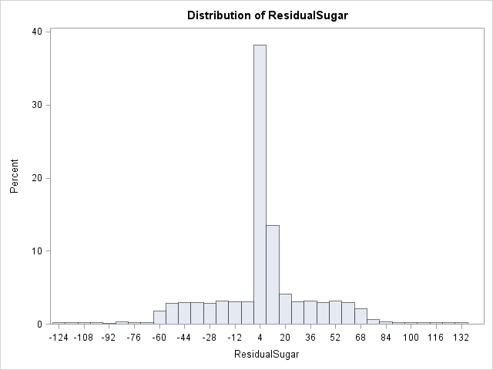 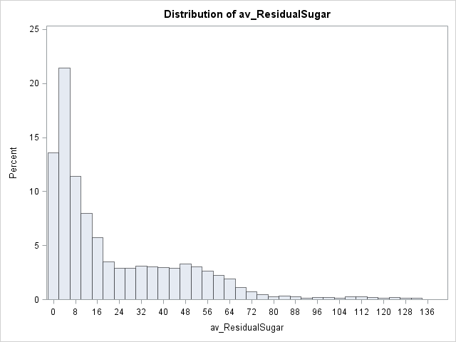

**pH**

pH is the measure of the degree of relative acidity versus the relative alkalinity of any liquid, on a scale of 0 to 14, with 7 being neutral. Winemakers use pH as a way to measure ripeness in relation to acidity. Low pH wines will taste tart and crisp, while higher pH wines are more susceptible to bacterial growth. Most wine pH's fall around 3 or 4; about 3.0 to 3.4 is desirable for white wines, while about 3.3 to 3.6 is best for red wines. Total acidity is another way of looking at similar things, this time measuring acidity by volume. The higher the pH, the lower the acidity, and the lower the pH, the higher the acidity. Most table wines will have a total acidity of about 0.6 to 0.7 percent.

While Total Acidity and pH may appear to be directly correlated as acidity indicators, they are not. The measurement of pH is the number of H+ ions in a solution using a logarithmic scale, with a lower number denoting a higher concentration of H+ ions. The measurement of acidic content is the acid’s potential to liberate H+ ions as it dissociates. While acid content affects pH, it is not directly predictive of pH or vice versa. This non-direct correlation is partially due to pH buffering caused by a number of compounds in wines, such as sugars, acids, and phenolic compounds. The addition of a given amount of acid to a wine may not reduce the pH as expected due to the wine’s buffering capacity to maintain a stable pH.4

The shape of the pH histogram resembles a plateau with low kurtosis except there is a large central spike at the mean value of 3.2076282 which is even more accentuated with imputed mean values. Most wines have a pH between 3 to 4, but about 25% of the observations are well below this range. Lemon juice has a pH of 2 and full strength acid has a pH of 0, so many of these wines are fatal to drink. Many of these pH values observations appear to be impossible values or a result of recording error. Since the sample size is greater than 2000, the Kolmogorov-Smirnov test is used to assess normality. The p-value < 0.01, so the normality assumption does not hold, meaning the data does not follow a normal distribution.

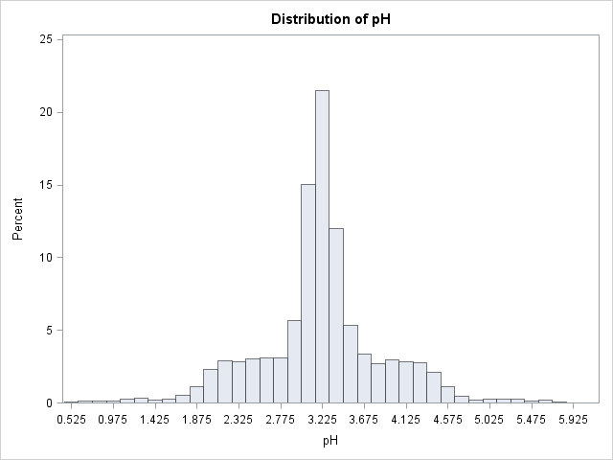

**FixedAcidity and av_FixedAcidity**

Acids are major wine constituents and contribute greatly to its taste. In fact, acids impart the sourness or tartness that is a fundamental feature in wine taste. Wines lacking in acid are flat tasting. Acidity affects taste, color, stability to oxidation, and consequently, the overall lifespan of a wine. The most abundant of these acids arise in the grapes themselves and carry over into the wine. However, there are also some acids that arise as a result of the fermentation process from either yeast and/or bacteria. Traditionally total acidity is divided into two groups, namely the volatile acids and the fixed (or nonvolatile) acids.

The predominant fixed acids found in wines are tartaric, malic, citric, and succinic acids. All of these fixed acids originate in grapes with the exception of succinic acid, which is produced by yeast during the fermentation process. Wines produced from cool climate grapes are high in acidity and thus taste sour. These high-acid wines can be treated to reduce the acidity, either by neutralizing agents, or by malolactic fermentation. Warm climate grapes can be low in acid, more or less depending on variety. In these areas tartaric acid, recycled from winemaking, is added to increase acidity and prevent wines from being flat.5

Tartaric and malic acids are produced by wine grapes as they develop. In warm climates, these acids are lost through the biochemical process of respiration. Therefore, grapes grown in warmer climates have lower acidity than grapes grown in cooler climates. Sugar production is the complete opposite of acid production. The warmer the climate the higher the sugar content of the grapes. In summary, warmer climates result in high sugar and low acid whereas cooler climates result in low sugar and high acid.

The shape of the FixedAcidity histogram resembles a plateau with low kurtosis except there is a large central spike at the mean value of 7.0757171. The av_FixedAcidity histogram very similarly shaped like a plateau with a large central spike. The Kolmogorov-Smirnov test for normality for both histograms results in a significant p-value (p < 0.01) which suggests that the data does not follow a normal distribution.

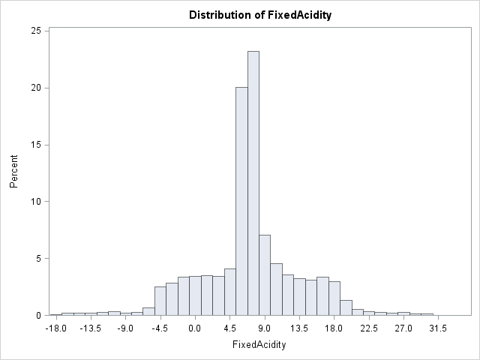 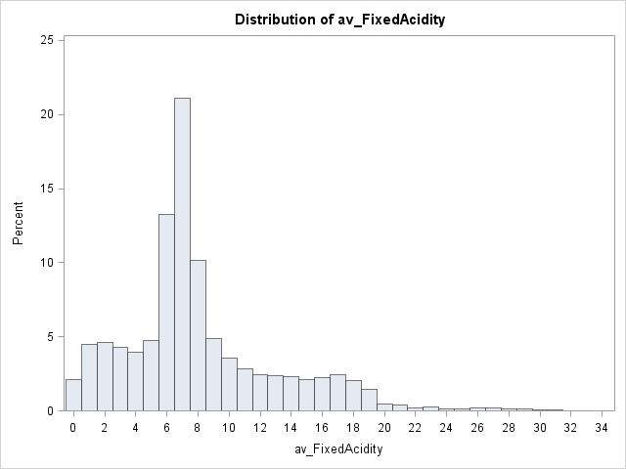

**VolatileAcidity and av_VolatileAcidity**

Volatile acidity refers to the steam distillable acids present in wine, primarily acetic acid but also lactic, formic, butyric, and propionic acids. Volatile acidity is closely associated with quality because it is an indication of spoilage. High levels of volatile acids are not desirable in wines. There are prevention and treatment methods to remove volatile acidity from a wine. The average level of acetic acid in a new dry table wine is less than 400 mg/L, though levels may range from undetectable up to 3 g/L. Acetic acid can be boiled off when heated. The amount of volatile acid is small with respect to total acidity. A volatile acidity measurement of 0.03-0.06% is produced during fermentation and is considered a normal level.

U.S. legal limits of Volatile Acidity:

* Red Table Wine 1.2 g/L
* White Table Wine 1.1 g/L

The aroma threshold for acetic acid in red wine varies from 600 mg/L and 900 mg/L, depending on the variety and style. While acetic acid is generally considered a spoilage product (vinegar), some winemakers seek a low or barely detectible level of acetic acid to add to the perceived complexity of a wine. In addition, the production of acetic acid will result in the concomitant formation of other, sometimes unpleasant, aroma compounds such as ethyl acetate and acetaldehyde. These compounds have a much lower sensory threshold than acetic acid. Both acetaldehyde and ethyl acetate are detectable at less than 200 mg/L in wine.6

The shape of the VolatileAcidity histogram resembles a plateau with low kurtosis except there is a large central spike at the mean value of 0.3241039. The Kolmogorov-Smirnov test for normality results in a significant p-value (p < 0.01) which suggests that the data does not follow a normal distribution. The av_VolatileAcidity histogram is highly positively skewed with practically no left half/tail of the curve. If the units of measurement are g/L, then both histograms have values above the U.S. legal limits of volatile acidity. This information should be factored into the decision of which wines to select. The Kolmogorov-Smirnov test for normality for both histograms results in a significant p-value (p < 0.01) which suggests that the data does not follow a normal distribution.

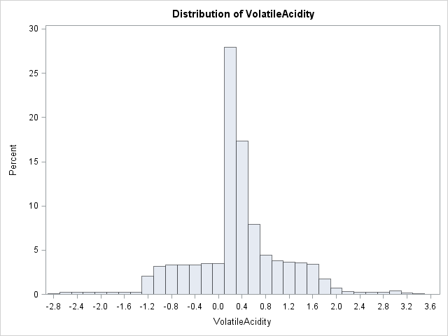 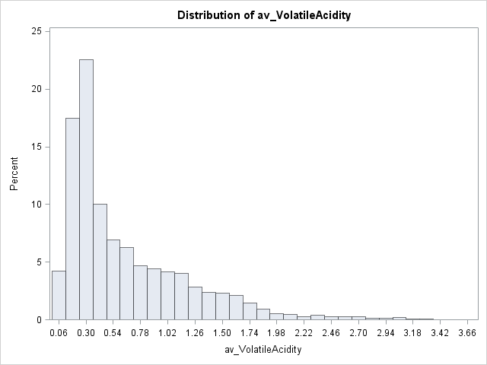

**TotalAcidity, av_TotalAcidity, and av_TotalAcidity2**

Total acidity takes into account all of the acids in wine. Interactions between the acids and the other chemical components are extremely complicated, yet each of these plays a role in the measurement of total acidity. The typical acidity measurements in wine are pH and total acidity. The pH measurement is used in the vineyard to assess the ripening pre-harvest to calculate sulfur dioxide requirements after fermentation, and to assess oxidation risk because high pH wines are generally more prone to oxidation. Total acidity is applied to sensory perception of a wine’s acidity (i.e. tartness, sourness, and crispness). While pH and total acidity are related, pH is a measurement of the likelihood and speed of occurrence of pH dependent reactions, while total acidity is the best estimate of a wines perceived acidity.

Technically, total acidity is not the same as titratable acidity. It is actually very difficult to accurately measure total acidity because you need to be able to directly quantify organic acids so most winemakers measure titratable acidity. While total acidity only quantifies the molar weights of acids contained in a grape, must or wine; titratable acidity is an approximation of total acidity by titration with a strong base to a pH of 8.2. For this assignment, I am approximating total acidity by adding together fixed acidity and volatile acidity.7

The shape of the TotalAcidity histogram resembles a plateau with low kurtosis except there is a large central spike at the mean value of 0.3241039. The Kolmogorov-Smirnov test for normality results in a significant p-value (p < 0.01) which suggests that the data does not follow a normal distribution. The av_TotalAcidity and av_TotalAcidity2 histograms are slightly positively skewed with longer right tails. The Kolmogorov-Smirnov test for normality for all 3 histograms results in a significant p-value (p < 0.01) which suggests that the data does not follow a normal distribution.

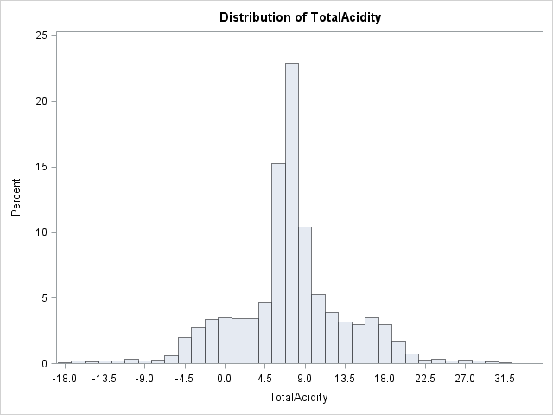

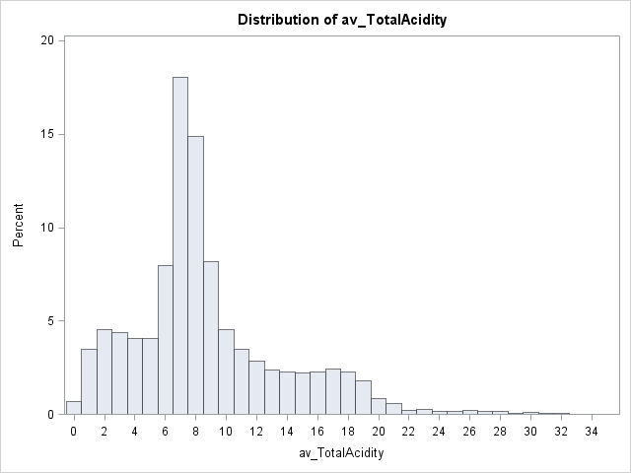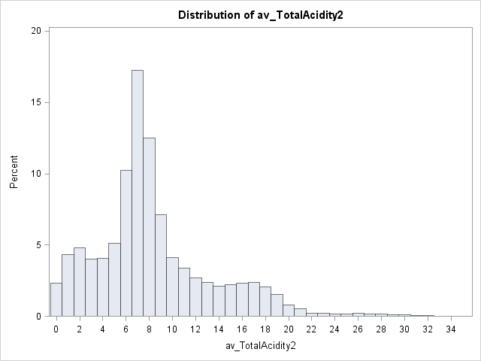

**Density**

Equipment such as hydrometers used to measure the density of wine give their readings in terms of specific gravity, which is the density of a liquid relative to pure water. Wines that are equally as dense as pure water have a specific gravity of 1. If a wine is denser than water, it will have a value over one. If its density is less than that of water, it will have a number between 0 and 1. The density of wine increases with more dissolved material and sugars make up most of the dissolved material. As yeast convert sugar to alcohol, the density of the must decreases, both from the loss of sugar and from the increase in alcohol, which is less dense than water. In this case, wine density is an indirect measurement of sugar and alcohol content.8,9

The shape of the Density histogram resembles a plateau with low kurtosis except there is a large central spike at the mean value of 0.9942027. The Kolmogorov-Smirnov test for normality results in a significant p-value (p < 0.01) which suggests that the data does not follow a normal distribution.

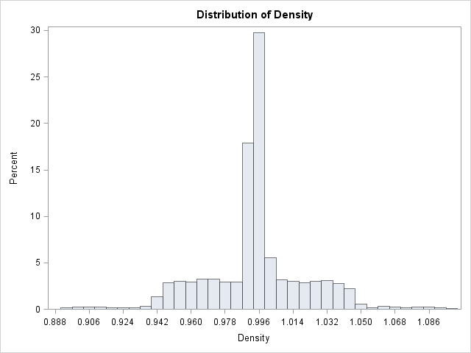

**CitricAcid and av_CitricAcid**

Citric acid is often added to wines to increase acidity, complement a specific flavor or prevent ferric hazes. It can be added to finished wines to increase acidity and give a fresh flavor. The disadvantage of adding citric acid is its microbial instability. Since bacteria use citric acid in their metabolism, it may increase the growth of unwanted microbes. Often to increase acidity of wine, winemakers will often add tartaric acid instead.10

The shape of the CitricAcid histogram resembles a plateau with low kurtosis except there is a large central spike at the mean value of 0.3084127. The histogram for av_CitricAcid is positively skewed with a long right tail. The Kolmogorov-Smirnov test for normality for both histograms results in a significant p-value (p < 0.01) which suggests that the data does not follow a normal distribution.

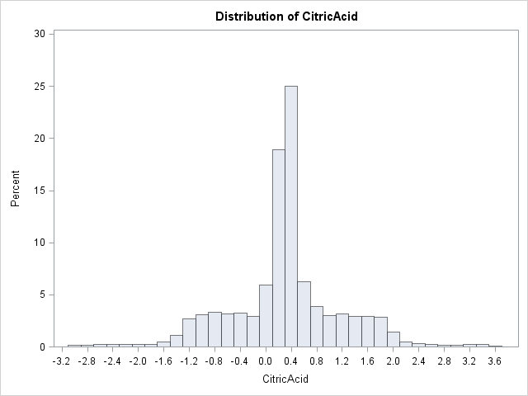 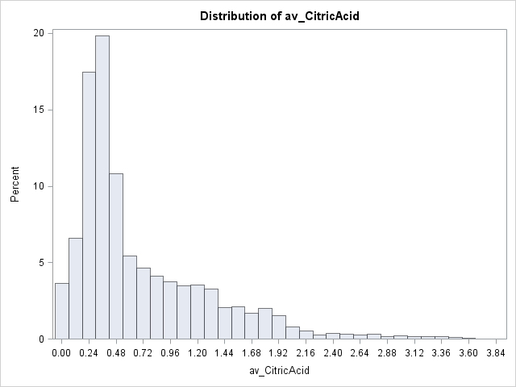

**Chlorides and av_Chlorides**

Wine contains from 2 to 4 g/L of salts of mineral acids and organic acids. These salts play a key role in the potential salty taste of a wine, with chlorides being a major contributor to saltiness. Moderate to large concentrations of chlorides and sodium might give the wine a salty flavor which may turn away potential consumers.11

The shape of the Chlorides histogram resembles a plateau with low kurtosis except there is a large central spike at the mean value of 0.0548225 which is accentuated with imputed mean values. The shape of the av_Chlorides histogram is highly positively skewed with practically no left half/tail of the curve. The Kolmogorov-Smirnov test for normality for both histograms results in a significant p-value (p < 0.01) which suggests that the data does not follow a normal distribution.

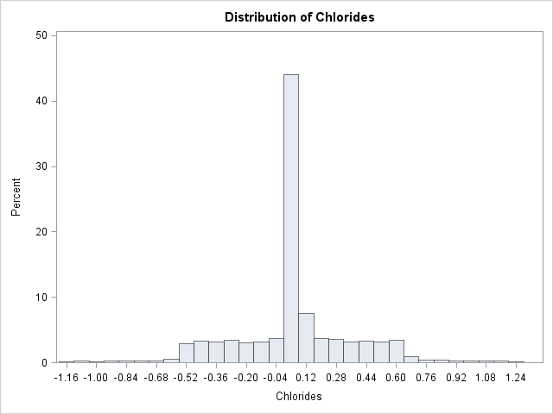 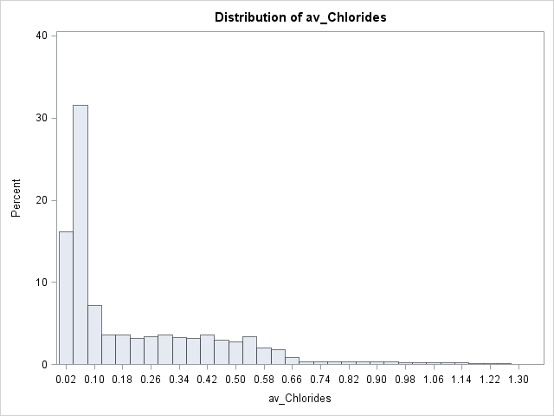

**Alcohol and av_Alcohol**

Recently, the alcohol content of wine has spiked considerably. There’s pressure on winemakers from critics for intense flavors, and that means riper grapes. During the past few years, winemakers have been leaving grapes on the vines well after they would typically be picked, and that translates into fuller-bodied wines and more alcohol. Alcohol content of wine ranges normally between 5% to 21%. Wines are normally classified as very low (under 12.5%), moderately low (12.5% to 13.5%), high (13.5% to 14.5%), and very high (more than 14.5%).12

The shape of the Alcohol histogram resembles a plateau with low kurtosis except there is a large central spike at the mean value of 10.4892363 which is accentuated with imputed mean values. The av_Alcohol histogram is similarly shaped like a plateau with a large central spike. The Kolmogorov-Smirnov test for normality for both histograms results in a significant p-value (p < 0.01) which suggests that the data does not follow a normal distribution.

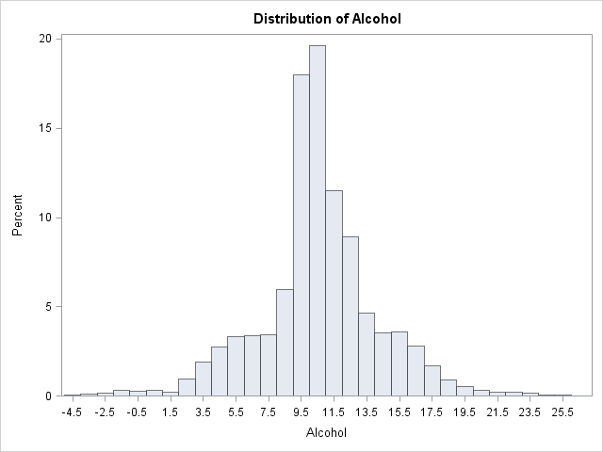 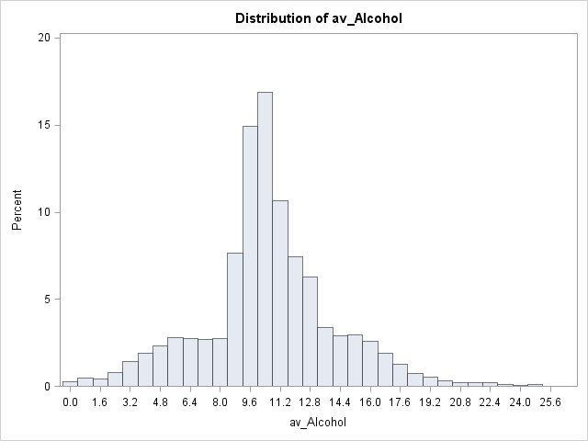

**AcidIndex**

Acid balance is a matter of taste and there is no set rule that determines the right acid balance. However, there are general guidelines to determine if acide balance is within the desired range for the type and style of wine. The formula for the AcidIndex (or Index of Acidity or Acid Taste Index) is to subtract pH from Total Acidity. Dry red wines should have an AcidIndex range of about 2 to 3, dry white wines about 2.7 to 3.7, and off-dry white wines about 3.8 to 4.8. AcidIndex numbers below these levels will result in flabby or soapy tasting wines while those far above them will taste sharp and acidic. Since the AcidIndex values of this data set are integers and peak between 7 and 8 with almost no values between 2 to 5, this may instead be a subjective rating of acidity from the wine consumer.13

The shape of the AcidIndex histogram resembles a normal distribution which is slightly positively skewed with a peak at the mean value of 7.7727237. The Kolmogorov-Smirnov test for normality results in a significant p-value (p < 0.01) which suggests that the data does not follow a normal distribution.

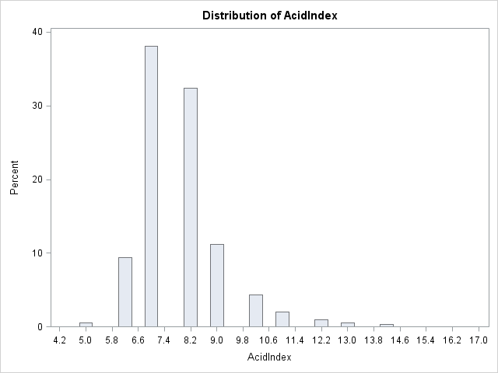

**LabelAppeal**

The histogram of LabelAppeal is shaped like a triangle pyramid with the peak at 0. Fortunately, there are no missing observations in LabelAppeal so there are no additional forms that need to be derived. I would expect that the most highly rated wine label designs (scores = 1 and 2) to be associated with a greater number of wine cases purchased and be the very highly correlated with TARGET.

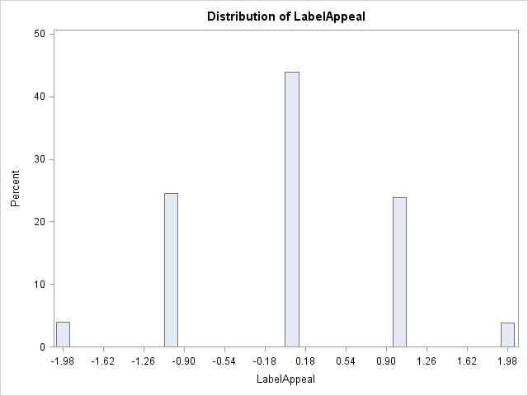

**STARS and STARS0**

For both STARS and STARS0, most of the wines are rated with a score of 0. The missing values imputed with the mean (in STARS) or set to 0 (in STARS0) make up a very large portion of the responses. I would expect that the most highly rated wines (3 and 4 stars) to be associated with a greater number of wine cases purchased and be the most strongly correlated predictor variable with TARGET.

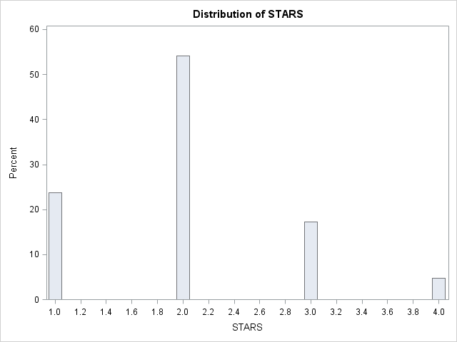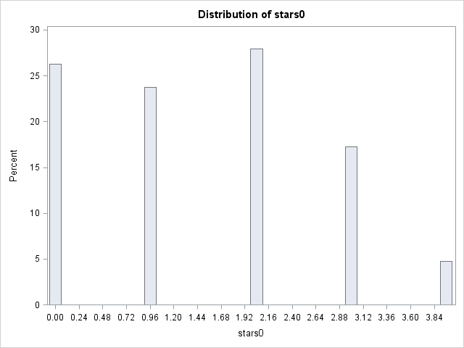

# 2. Data Preparation

**Addressing missing observations**

As mentioned in the last section, there are many variables have missing observations in the data set, most notably STARS with the most at 3359. For the continuous variables, I imputed the missing values with the mean value. For STARS, which I will also use as a categorical variable, I rounded the mean value to the nearest integer and created a binary indicator variable to flag when the data is missing.

**Addressing negative values**

Many of the variables have negative values which do not make sense because they are a frequency, amount, or concentration of a particular substance which can only take on positive values, including: Alcohol, Chlorides, CitricAcid, FixedAcidity, FreeSulfurDioxide, ResidualSugar, Sulphates, TotalSulfurDioxide, and VolatileAcidity. I added the absolute value of the minimum negative value to all of the observations of variables with negative values to make sure the whole distribution is positive with a minimum value of 0. These new “reshifted” variables were renamed with the prefix “rs_”. I also applied the absolute value to variables with negative values to make sure all of the observations were positive. These new absolute value transformed variables were renamed with the prefix “av_”.

**Adding new variables**

I renamed Sulphates to Sulfites. I added a “0” class for the missing values of STARS to make STARS0. I also derived BoundSulfurDioxide variables and TotalAcidity variables from existing variables.

New BoundSulfurDioxide Variables added:

* BoundSulfurDioxide = TotalSulfurDioxide - FreeSulfurDioxide
  + with its missing values replaced by its mean value
* BoundSulfurDioxide2 = TotalSulfurDioxide - FreeSulfurDioxide
  + after the missing values from TotalSulfurDioxide and FreeSulfurDioxide have had their missing values imputed with their mean values
* rs_BoundSulfurDioxide = abs(rs_TotalSulfurDioxide – rs_FreeSulfurDioxide)
* rs_BoundSulfurDioxide2 = BoundSulfurDioxide + abs(min(BoundSulfurDioxide))
* av_BoundSulfurDioxide = abs(abs(TotalSulfurDioxide) – abs(FreeSulfurDioxide))
* av_BoundSulfurDioxide2 = abs(BoundSulfurDioxide2)

New TotalAcidity variables added:

* TotalAcidity = FixedAcidity + VolatileAcidity
* rs_TotalAcidity = abs(rs_FixedAcidity + rs_VolatileAcidity)
* rs_TotalAcidity2 = TotalAcidity + abs(min(TotalAcidity))
* av_TotalAcidity = abs(abs(FixedAcidity) + abs(VolatileAcidity))
* av_TotalAcidity2 = abs(TotalAcidity)

Almost all of the absolute value transformed variables plus AcidIndex were positively skewed. Therefore, I added the natural logarithm and square root transform of all of the “av_” prefix variables plus AcidIndex in order to make the distribution appear more normal. The chart below details all of the new variables added.

|  |  |  |
| --- | --- | --- |
| **Derived from original variables** | **Indicator variables for missing values** | **Reshifted** |
| BoundSulfurDioxide | I_Alcohol | rs_Alcohol |
| BoundSulfurDioxide2 | I_BoundSulfurDioxide | rs_Chlorides |
| TotalAcidity | I_Chlorides | rs_CitricAcid |
| STARS0 | I_FreeSulfurDioxide | rs_FixedAcidity |
|  | I_ResidualSugar | rs_FreeSulfurDioxide |
|  | I_STARS | rs_ResidualSugar |
|  | I_Sulfites | rs_Sulfites |
|  | I_TotalSulfurDioxide | rs_TotalSulfurDioxide |
|  | I_pH | rs_VolatileAcidity |
|  |  | rs_BoundSulfurDioxide |
|  |  | rs_BoundSulfurDioxide2 |
|  |  | rs_TotalAcidity |
|  |  | rs_TotalAcidity2 |

|  |  |  |
| --- | --- | --- |
| **Absolute Value** | **Natural Logarithm** | **Square Root** |
| av_Alcohol | ln_av_Alcohol | sr_av_Alcohol |
| av_Chlorides | ln_av_Chlorides | sr_av_Chlorides |
| av_CitricAcid | ln_av_CitricAcid | sr_av_CitricAcid |
| av_FixedAcidity | ln_av_FixedAcidity | sr_av_FixedAcidity |
| av_FreeSulfurDioxide | ln_av_FreeSulfurDioxide | sr_av_FreeSulfurDioxide |
| av_ResidualSugar | ln_av_ResidualSugar | sr_av_ResidualSugar |
| av_Sulfites | ln_av_Sulfites | sr_av_Sulfites |
| av_TotalSulfurDioxide | ln_av_TotalSulfurDioxide | sr_av_TotalSulfurDioxide |
| av_VolatileAcidity | ln_av_VolatileAcidity | sr_av_VolatileAcidity |
| av_BoundSulfurDioxide | ln_av_BoundSulfurDioxide | sr_av_BoundSulfurDioxide |
| av_BoundSulfurDioxide2 | ln_av_BoundSulfurDioxide2 | sr_av_BoundSulfurDioxide2 |
| av_TotalAcidity | ln_av_TotalAcidity | sr_av_TotalAcidity |
| av_TotalAcidity2 | ln_av_TotalAcidity2 | sr_av_TotalAcidity2 |
|  | ln_AcidIndex | sr_AcidIndex |

# 3. Build Models

Next, I examine the correlations of all the variables with TARGET. The correlation table below lists the correlation coefficients by largest to smallest. It makes sense that the 3 subjective rating variables: STARS, LabelAppeal, and AcidIndex are among the most highly correlated variables to TARGET. Since they are so highly correlated with TARGET, I may not have to use them as categorical variables. I am not surprised that STARS and STARS0 are in the top 3 of most correlated with TARGET as both are subjective ratings of wine quality. However, it is surprising that I_STARS is the second most correlated with TARGET. Perhaps the wines that were not rated were, on average, actually low quality wines and were not highly purchased. In fact, Sulfur dioxide levels, acidity levels, and alcohol content are all truly subjective measures because they vary and are dependent upon the type of wine that most appeals to the consumer. I expect volatile, fixed, total acidity, and pH correlation coefficients to be in the same region of the chart. VolatileAcidity variables are the most correlated with TARGET and FixedAcidity variables are the least correlated of the 3 acidity variables. However, pH is very far away from the acidity variables appearing near the bottom of the chart, which means it is not a similar acidity measurement.

|  |  |
| --- | --- |
| **Correlation with TARGET** | |
| **Variable** | **Correlation** |
| STARS0 | 0.68538 | ln_av_Chlorides | -0.05251 | av_FreeSulfurDioxide | 0.0236 |
| i_stars | -0.57158 | TotalSulfurDioxide | 0.0501 | BoundSulfurDioxide | 0.02141 |
| STARS | 0.40013 | rs_TotalSulfurDioxide | 0.0501 | rs_BoundSulfurDioxide2 | 0.02141 |
| LabelAppeal | 0.3565 | FixedAcidity | -0.04901 | ln_av_ResidualSugar | 0.01931 |
| AcidIndex | -0.24605 | rs_FixedAcidity | -0.04901 | BoundSulfurDioxide2 | 0.0192 |
| sr_AcidIndex | -0.24311 | ln_av_Alcohol | 0.04897 | rs_BoundSulfurDioxide | 0.01618 |
| ln_AcidIndex | -0.23847 | ln_av_TotalAcidity | -0.04882 | ResidualSugar | 0.01607 |
| VolatileAcidity | -0.08879 | sr_av_FixedAcidity | -0.04841 | rs_ResidualSugar | 0.01607 |
| rs_VolatileAcidity | -0.08879 | sr_av_FreeSulfurDioxide | 0.04323 | sr_av_BoundSulfurDioxide2 | 0.01399 |
| ln_av_TotalSulfurDioxide | 0.08617 | FreeSulfurDioxide | 0.04269 | av_CitricAcid | 0.01395 |
| ln_av_VolatileAcidity | -0.08405 | rs_FreeSulfurDioxide | 0.04269 | i_sulfites | -0.0125 |
| sr_av_VolatileAcidity | -0.08106 | sr_av_Chlorides | -0.03852 | ln_av_BoundSulfurDioxide | 0.01209 |
| ln_av_FreeSulfurDioxide | 0.07774 | ln_av_Sulfites | -0.03805 | i_residualsugar | 0.0112 |
| av_VolatileAcidity | -0.07019 | Chlorides | -0.03724 | i_ph | -0.00997 |
| av_TotalAcidity2 | -0.06248 | rs_Chlorides | -0.03724 | pH | -0.00928 |
| av_Alcohol | 0.06173 | Sulfites | -0.03691 | sr_av_ResidualSugar | 0.00922 |
| Alcohol | 0.06043 | rs_Sulfites | -0.03691 | CitricAcid | 0.00868 |
| rs_Alcohol | 0.06043 | sr_av_Sulfites | -0.03557 | rs_CitricAcid | 0.00868 |
| av_TotalAcidity | -0.06035 | Density | -0.03552 | av_BoundSulfurDioxide2 | 0.00685 |
| TotalAcidity | -0.05948 | ln_av_FixedAcidity | -0.03409 | i_totalsulfurdioxide | 0.00617 |
| rs_TotalAcidity | -0.05948 | av_TotalSulfurDioxide | 0.03334 | av_BoundSulfurDioxide | -0.00531 |
| rs_TotalAcidity2 | -0.05948 | av_Sulfites | -0.03127 | i_boundsulfurdioxide | 0.00469 |
| sr_av_Alcohol | 0.05845 | sr_av_CitricAcid | 0.03 | i_chlorides | 0.00269 |
| sr_av_TotalAcidity | -0.05798 | ln_av_CitricAcid | 0.02781 | av_ResidualSugar | 0.00176 |
| sr_av_TotalSulfurDioxide | 0.05779 | av_Chlorides | -0.02778 | i_alcohol | 0.00148 |
| sr_av_TotalAcidity2 | -0.05576 | ln_av_BoundSulfurDioxide2 | 0.0262 | sr_av_BoundSulfurDioxide | 0.00103 |
| av_FixedAcidity | -0.05298 | ln_av_TotalAcidity2 | -0.02602 | i_freesulfurdioxide | -0.00015 |

The original data set included 14 predictor variables. I think a model with 9 or a little over half of the number of predictor variables should make the most accurate predictions while remaining parsimonious. I will only take one form of the variables with the highest correlation coefficients to prevent multicollinearity problems. Based on this chart, I can narrow down an initial list of candidate variables to include in my model: STARS0, LabelAppeal, AcidIndex, rs_VolatileAcidity, ln_av_TotalSulfurDioxide, ln_av_FreeSulfurDioxide, rs_TotalAcidity2, and av_Alcohol.

|  |
| --- |
| stars0 |
| LabelAppeal |
| AcidIndex |
| VolatileAcidity |
| ln_av_TotalSulfurDioxide |
| ln_av_FreeSulfurDioxide |
| rs_TotalAcidity2 |
| av_Alcohol |
| av_Fixed_Acidity |

It will be interesting to potentially use 3 subjective variables and 6 physical variables. Additionally, none of these variables appear to be highly correlated to each other so there should not be any multicollinearity problems.

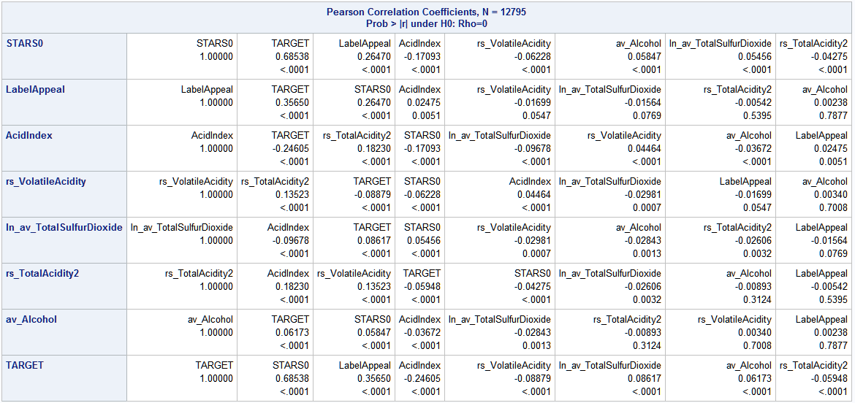

The GENMOD procedures in SAS do not provide us with a method for automatic variable selection. Therefore, I will have to use PROC HPGENSELECT (available with SAS 9.4) to conduct automated variable selection for Poisson and Negative Binomial models. For linear regression models I will apply PROC REG to utilize the automated variable selection methods to find the best variables to include in my model. Then, I will examine different combinations of variables with different models and compare their respective performance in predicting TARGET.

With HPGENSELECT with poisson link function and logarithm distribution (link=poi, dist=log) using stepwise variable selection with an entry significance level of 0.05 (SLENTRY = 0.05) and stay significance level of 0.05 (SLSTAY = 0.05), the first 9 unique variables to be added and stay in the model are: STARS0, LabelAppeal, AcidIndex, ln_av_TotalSulfurDioxide, ln_av_VolatileAcidity, ln_av_FreeSulfurDioxide, av_Alcohol, BoundSulfurDioxide, and ln_av_chlorides. When I use a negative binomial link function keeping all other settings the same, the first 9 unique variables to be added and stay in the model are the same as with a poisson link function. When I use an identity link function keeping all other settings the same, and normal distribution, the first 9 unique variables remain the same except for av_BoundSulfurDioxide.

|  |  |
| --- | --- |
| stars0 | stars0 |
| LabelAppeal | LabelAppeal |
| AcidIndex | AcidIndex |
| ln_av_TotalSulfurDioxide | ln_av_TotalSulfurDioxide |
| ln_av_VolatileAcidity | ln_av_VolatileAcidity |
| ln_av_FreeSulfurDioxide | ln_av_FreeSulfurDioxide |
| av_Alcohol | av_Alcohol |
| BoundSulfurDioxide | av_BoundSulfurDioxide |
| ln_av_chlorides | ln_av_chlorides |

When I make STARS, STARS0, I_STARS, and LabelAppeal categorical variables and otherwise keep the same settings, the first 9 unique variables to be added and stay in the model are: STARS0, LabelAppeal, AcidIndex, VolatileAcidity, ln_av_TotalSulfurDioxide, av_BoundSulfurDioxide, av_Alcohol, ln_av_FreeSulfurDioxide, and ln_av_chlorides. When I use a negative binomial link function keeping all other settings the same, the first 9 unique variables are the same as with a poisson link function. When I use an identity link function keeping all other settings the same, and normal distribution, the first 9 unique variables remain the same except for ln_av_VolatileAcidity.

|  |  |
| --- | --- |
| stars0 | stars0 |
| LabelAppeal | LabelAppeal |
| AcidIndex | AcidIndex |
| VolatileAcidity | ln_av_VolatileAcidity |
| ln_av_TotalSulfurDioxide | ln_av_TotalSulfurDioxide |
| av_BoundSulfurDioxide | av_BoundSulfurDioxide |
| av_Alcohol | av_Alcohol |
| ln_av_FreeSulfurDioxide | ln_av_FreeSulfurDioxide |
| ln_av_chlorides | ln_av_chlorides |

Putting the tables of selected variables together and reordering the variables, I find that 6 of the variables are represented at least 4 times in 4 lists (highlighted in yellow) and 2 variables are represented at least 3 times in 3 lists (highlighted in blue).

|  |  |  |  |  |
| --- | --- | --- | --- | --- |
| **Top 9 Selected from Correlation Table** | **Top 9 from Stepwise variable selection with all quantitative variables** | | **Top 9 from Stepwise variable selection with 4 categorical variables** | |
| stars0 | stars0 | stars0 | stars0 | stars0 |
| LabelAppeal | LabelAppeal | LabelAppeal | LabelAppeal | LabelAppeal |
| AcidIndex | AcidIndex | AcidIndex | AcidIndex | AcidIndex |
| VolatileAcidity | ln_av_TotalSulfurDioxide | ln_av_TotalSulfurDioxide | VolatileAcidity | ln_av_VolatileAcidity |
| ln_av_TotalSulfurDioxide | ln_av_VolatileAcidity | ln_av_VolatileAcidity | ln_av_TotalSulfurDioxide | ln_av_TotalSulfurDioxide |
| ln_av_FreeSulfurDioxide | ln_av_FreeSulfurDioxide | ln_av_FreeSulfurDioxide | av_BoundSulfurDioxide | av_BoundSulfurDioxide |
| rs_TotalAcidity2 | av_Alcohol | av_Alcohol | av_Alcohol | av_Alcohol |
| av_Alcohol | BoundSulfurDioxide | av_BoundSulfurDioxide | ln_av_FreeSulfurDioxide | ln_av_FreeSulfurDioxide |
| av_Fixed_Acidity | ln_av_chlorides | ln_av_chlorides | ln_av_chlorides | ln_av_chlorides |

Normally, I would limit the selected variable subset to the 6 variables that appear 4 times in 4 lists. However, ln_av_VolatileAcidity is the first non-subjective physical measurement variable (along with ln_av_TotalSulfurDioxide) so it must be an important predictor variable. I do not choose to include av_BoundSulfurDioxide because it is formed from combining of TotalSulfurDioxide and FreeSulfurDioxide, both of which appear earlier/higher on the lists. Although ln_av_chlorides is represented 4 times in 4 lists, it very relatively low on the correlation table appearing at the top of the second column (in the chart above) while all of the other 7 variables appear in the closely together in the top half of the first column. In the table, av_alcohol, the last of the 7 variables grouped together, is #16, while ln_av_chlorides is #28. There is a big jump between these 2 variables. There are even 2 unique variable types, TotalAcidity (TotalAcidity2) and FixedAcidity that appear in the big gap between these 2 variables.

|  |  |  |
| --- | --- | --- |
| **Correlation with TARGET (first 29)** | | |
| **Position** | **Variable** | **Correlation** |
| 1 | STARS0 | 0.68538 |
| 2 | i_stars | -0.57158 |
| 3 | STARS | 0.40013 |
| 4 | LabelAppeal | 0.3565 |
| 5 | AcidIndex | -0.24605 |
| 6 | sr_AcidIndex | -0.24311 |
| 7 | ln_AcidIndex | -0.23847 |
| 8 | VolatileAcidity | -0.08879 |
| 9 | rs_VolatileAcidity | -0.08879 |
| 10 | ln_av_TotalSulfurDioxide | 0.08617 |
| 11 | ln_av_VolatileAcidity | -0.08405 |
| 12 | sr_av_VolatileAcidity | -0.08106 |
| 13 | ln_av_FreeSulfurDioxide | 0.07774 |
| 14 | av_VolatileAcidity | -0.07019 |
| 15 | av_TotalAcidity2 | -0.06248 |
| 16 | av_Alcohol | 0.06173 |
| 17 | Alcohol | 0.06043 |
| 18 | rs_Alcohol | 0.06043 |
| 19 | av_TotalAcidity | -0.06035 |
| 20 | TotalAcidity | -0.05948 |
| 21 | rs_TotalAcidity | -0.05948 |
| 22 | rs_TotalAcidity2 | -0.05948 |
| 23 | sr_av_Alcohol | 0.05845 |
| 24 | sr_av_TotalAcidity | -0.05798 |
| 25 | sr_av_TotalSulfurDioxide | 0.05779 |
| 26 | sr_av_TotalAcidity2 | -0.05576 |
| 27 | av_FixedAcidity | -0.05298 |
| 28 | ln_av_Chlorides | -0.05251 |

I will continue with the following subset of 7 variables, once with STARS0 and LabelAppeal as quantitative variables, and once with stars0 and LabelAppeal as categorical variables for each of the models.

|  |
| --- |
| **Selected Variables** |
| stars0 |
| LabelAppeal |
| AcidIndex |
| ln_av_VolatileAcidity |
| ln_av_TotalSulfurDioxide |
| av_Alcohol |
| ln_av_FreeSulfurDioxide |

For Poisson and Negative Binomial models using PROC GENMOD I continue to examine this subset of variables by attempting to explore comprehensively what variables make sense to incorporate. This becomes more difficult when working with the Zero Inflated variants of the model as I will need to produce frequency tables to examine which variables conditionally contribute to the probability that would result in a zero count in the TARGET. I expect to see very similar models from the Poisson and Negative Binomial approaches due to the TARGET variance being close to equal with the TARGET mean.

**Model 1: GENMOD with Poisson distribution and all quantitative variables**

The following interpretations assume that all other variables are held constant.

* Assuming that all variables are zero, the logarithm of expected number of wine cases purchased would be 0.8933
* If a wine increased its stars0 rating by 1 point, the logarithm of expected number of wine cases purchased would be expected to increase by 0.3114.
* If a wine increased its LabelAppeal score by 1 point, the logarithm of expected number of wine cases purchased would be expected to increase by 0.1339.
* If a wine increased its AcidIndex score by 1 point, the logarithm of expected number of wine cases purchased would be expected to decrease by 0.0848.
* If a wine increased its natural logarithm, absolute value transformed Volatile Acidity content by 1 unit, the logarithm of expected number of wine cases purchased would be expected to decrease by 0.0293.
* If a wine increased its natural logarithm, absolute value transformed Total Sulfur Dioxide content by 1 unit, the logarithm of expected number of wine cases purchased would be expected to increase by 0.0347.
* If a wine increased its natural logarithm, absolute value transformed Free Sulfur Dioxide rating by 1 unit, the logarithm of expected number of wine cases purchased would be expected to increase by 0.0187.
* If a wine increased it absolute value transformed alcohol content by 1 unit, the logarithm of expected number of wine cases purchased would be expected to increase by 0.0028.

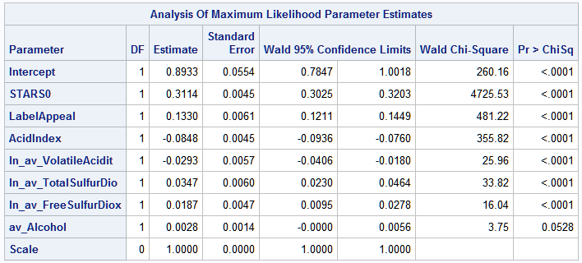

The Deviance, Log Likelihood, AIC, AICC, and BIC are all fairly high. I will need to compare these values with those of other models to pick the best model.

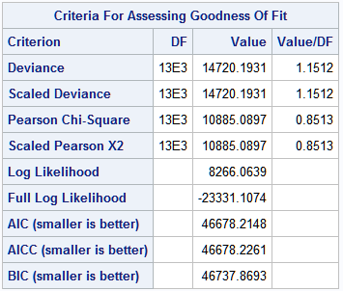

**Model 2: GENMOD with Poisson distribution and STARS0 and LabelAppeal as categorical variables**

In the case of the categorical variables with a Poisson distribution, the exponentiated coefficient is the multiplicative term relative to the base level for each variable. The exponentiated intercept is the baseline rate, and all other estimates will be relative to it.

The following interpretations assume that all other variables are held constant.

* Assuming that all variables are zero (STARS0 at 0 and LabelAppeal at -2), the logarithm of expected number of wine cases purchased would be 0.1413.
* Given that STARS0 has a base level of 0 (lowest rating), we interpret obtaining a:
  + 1 rating: 0.7676 increase in the logarithm of expected number of cases purchased
  + 2 rating: 1.0838 increase in the logarithm of expected number of cases purchased
  + 3 rating: 1.2051 increase in the logarithm of expected number of cases purchased
  + 4 rating: 1.3272 increase in the logarithm of expected number of cases purchased
* Given that LabelAppeal has a base level of -2 (lowest rating), we interpret obtaining a:
  + -1 rating: 0.2381 increase in the logarithm of expected number of cases purchased
  + 0 rating: 0.4274 increase in the logarithm of expected number of cases purchased
  + +1 rating: 0.5602 increase in the logarithm of expected number of cases purchased
  + +2 rating: 0.6962 increase in the logarithm of expected number of cases purchased
* If a wine increased its AcidIndex score by 1 point, the logarithm of expected number of wine cases purchased would be expected to decrease by 0.0778.
* If a wine increased its natural logarithm, absolute value transformed Volatile Acidity content by 1 unit, the logarithm of expected number of wine cases purchased would be expected to decrease by 0.0262.
* If a wine increased its natural logarithm, absolute value transformed Total Sulfur Dioxide content by 1 unit, the logarithm of expected number of wine cases purchased would be expected to increase by 0.0283.
* If a wine increased its natural logarithm, absolute value transformed Free Sulfur Dioxide rating by 1 unit, the logarithm of expected number of wine cases purchased would be expected to increase by 0.0156.
* If a wine increased it absolute value transformed alcohol content by 1 unit, the logarithm of expected number of wine cases purchased would be expected to increase by 0.0043.

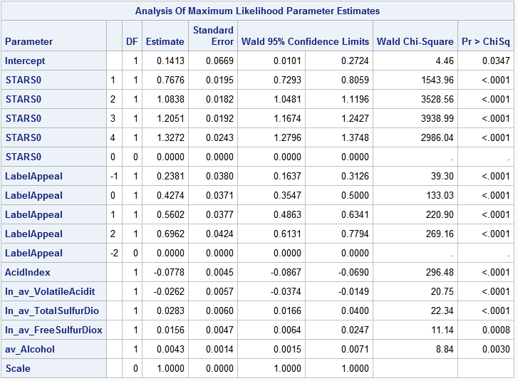

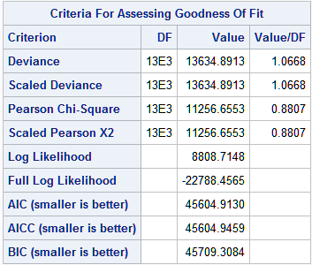

**Model 3: GENMOD with Negative Binomial distribution and all quantitative variables**

The parameter estimates are the same as in model 1 but the Goodness of Fit criteria are different.

The following interpretations assume that all other variables are held constant.

* Assuming that all variables are zero, the logarithm of expected number of wine cases purchased would be 0.8933
* If a wine increased its stars0 rating by 1 point, the logarithm of expected number of wine cases purchased would be expected to increase by 0.3114.
* If a wine increased its LabelAppeal score by 1 point, the logarithm of expected number of wine cases purchased would be expected to increase by 0.1339.
* If a wine increased its AcidIndex score by 1 point, the logarithm of expected number of wine cases purchased would be expected to decrease by 0.0848.
* If a wine increased its natural logarithm, absolute value transformed Volatile Acidity content by 1 unit, the logarithm of expected number of wine cases purchased would be expected to decrease by 0.0293.
* If a wine increased its natural logarithm, absolute value transformed Total Sulfur Dioxide content by 1 unit, the logarithm of expected number of wine cases purchased would be expected to increase by 0.0347.
* If a wine increased its natural logarithm, absolute value transformed Free Sulfur Dioxide rating by 1 unit, the logarithm of expected number of wine cases purchased would be expected to increase by 0.0187.
* If a wine increased it absolute value transformed alcohol content by 1 unit, the logarithm of expected number of wine cases purchased would be expected to increase by 0.0028.

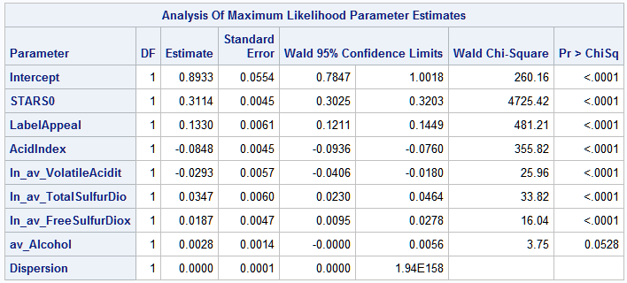

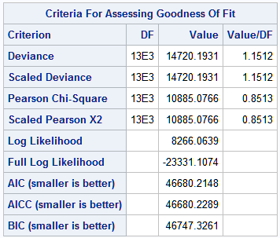

**Model 4: GENMOD with Negative Binomial distribution and STARS0 and LabelAppeal as categorical variables**

The parameter estimates are the same as in model 2 but the Goodness of Fit criteria are different.

The following interpretations assume that all other variables are held constant.

* Assuming that all variables are zero (STARS0 at 0 and LabelAppeal at -2), the logarithm of expected number of wine cases purchased would be 0.1413.
* Given that STARS0 has a base level of 0 (lowest rating), we interpret obtaining a:
  + 1 rating: 0.7676 increase in the logarithm of expected number of cases purchased
  + 2 rating: 1.0838 increase in the logarithm of expected number of cases purchased
  + 3 rating: 1.2051 increase in the logarithm of expected number of cases purchased
  + 4 rating: 1.3272 increase in the logarithm of expected number of cases purchased
* Given that LabelAppeal has a base level of -2 (lowest rating), we interpret obtaining a:
  + -1 rating: 0.2381 increase in the logarithm of expected number of cases purchased
  + 0 rating: 0.4274 increase in the logarithm of expected number of cases purchased
  + +1 rating: 0.5602 increase in the logarithm of expected number of cases purchased
  + +2 rating: 0.6962 increase in the logarithm of expected number of cases purchased
* If a wine increased its AcidIndex score by 1 point, the logarithm of expected number of wine cases purchased would be expected to decrease by 0.0778.
* If a wine increased its natural logarithm, absolute value transformed Volatile Acidity content by 1 unit, the logarithm of expected number of wine cases purchased would be expected to decrease by 0.0262.
* If a wine increased its natural logarithm, absolute value transformed Total Sulfur Dioxide content by 1 unit, the logarithm of expected number of wine cases purchased would be expected to increase by 0.0283.
* If a wine increased its natural logarithm, absolute value transformed Free Sulfur Dioxide rating by 1 unit, the logarithm of expected number of wine cases purchased would be expected to increase by 0.0156.
* If a wine increased it absolute value transformed alcohol content by 1 unit, the logarithm of expected number of wine cases purchased would be expected to increase by 0.0043.

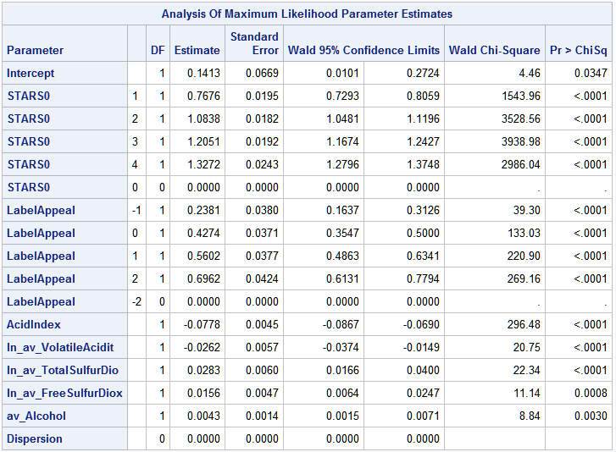

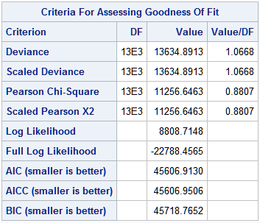

**Model 5:** **GENMOD with Zero Inflated Poisson distribution and all quantitative variables**

I produce frequency tables and histograms of the 7 variables and find that STARS0, LabelAppeal, and AcidIndex all have large zero count and are zero inflated. I will incorporate these 3 variables into the zeromodel as they may conditionally contribute to the probability of observing a zero count in the target variable.

The following interpretations assume that all other variables are held constant.

* Assuming that all variables are zero, the logarithm of expected number of wine cases purchased would be 1.1244.
* If a wine increased its stars0 rating by 1 point, the logarithm of expected number of wine cases purchased would be expected to increase by 0.1013.
* If a wine increased its LabelAppeal score by 1 point, the logarithm of expected number of wine cases purchased would be expected to increase by 0.2332.
* If a wine increased its AcidIndex score by 1 point, the logarithm of expected number of wine cases purchased would be expected to decrease by 0.0187.
* If a wine increased its natural logarithm, absolute value transformed Volatile Acidity content by 1 unit, the logarithm of expected number of wine cases purchased would be expected to decrease by 0.0138.
* If a wine increased its natural logarithm, absolute value transformed Total Sulfur Dioxide content by 1 unit, the logarithm of expected number of wine cases purchased would be expected to increase by 0.0027.
* If a wine increased its natural logarithm, absolute value transformed Free Sulfur Dioxide rating by 1 unit, the logarithm of expected number of wine cases purchased would be expected to increase by 0.0062.
* If a wine increased it absolute value transformed alcohol content by 1 unit, the logarithm of expected number of wine cases purchased would be expected to increase by 0.0069.

For the zero inflated parameter estimates, assuming that all other variables are held constant:

* If all of the predictor variables in the model are evaluated at zero, the log odds of the predicted number of wine cases purchased being zero would be 0.050545.
* If a wine increased its STARS0 rating by 1 point, the odds of the expected number wine cases purchased being zero would decrease by a factor of 0.093462 and by 90.65%.
* If a wine increased its LabelAppeal score by 1 point, odds of the expected number wine cases purchased would increase by a factor of 2.048525 and by 104.85%.
* If a wine increased its AcidIndex score by 1 point, odds of the expected number wine cases purchased would increase by a factor of 1.547901 and by 54.79%.

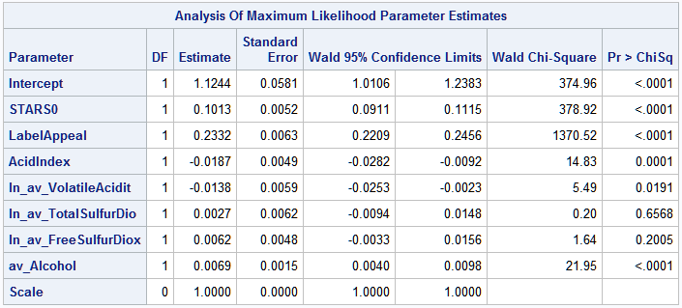

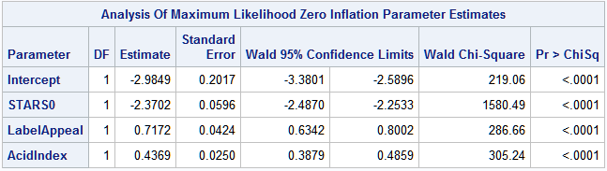

|  |  |  |  |
| --- | --- | --- | --- |
| **Variable** | **Estimate** | **exp(β)** | **exp(β)-1** |
| Intercept | -2.9849 | 0.050545 | -0.94946 |
| STARS0 | -2.3702 | 0.093462 | -0.90654 |
| LabelAppeal | 0.71712 | 2.048525 | 1.048525 |
| AcidIndex | 0.4369 | 1.547901 | 0.547901 |

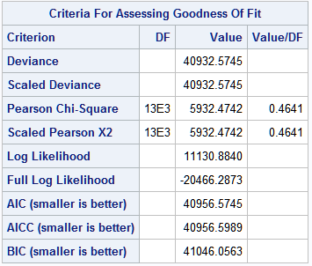

**Model 6: GENMOD with Zero Inflated Poisson distribution and STARS0 and LabelAppeal as categorical variables**

The following interpretations assume that all other variables are held constant.

* Assuming that all variables are zero (STARS0 at 0 and LabelAppeal at -2), the logarithm of expected number of wine cases purchased would be 0.4532.
* Given that STARS0 has a base level of 0 (lowest rating), we interpret obtaining a:
  + 1 rating: 0.0632 increase in the logarithm of expected number of cases purchased
  + 2 rating: 0.1834 increase in the logarithm of expected number of cases purchased
  + 3 rating: 0.2816 increase in the logarithm of expected number of cases purchased
  + 4 rating: 0.3809 increase in the logarithm of expected number of cases purchased
* Given that LabelAppeal has a base level of -2 (lowest rating), we interpret obtaining a:
  + -1 rating: 0.4432 increase in the logarithm of expected number of cases purchased
  + 0 rating: 0.7311 increase in the logarithm of expected number of cases purchased
  + +1 rating: 0.9213 increase in the logarithm of expected number of cases purchased
  + +2 rating: 1.0785 increase in the logarithm of expected number of cases purchased
* If a wine increased its AcidIndex score by 1 point, the logarithm of expected number of wine cases purchased would be expected to decrease by 0.0191.
* If a wine increased its natural logarithm, absolute value transformed Volatile Acidity content by 1 unit, the logarithm of expected number of wine cases purchased would be expected to decrease by 0.0135.
* If a wine increased its natural logarithm, absolute value transformed Total Sulfur Dioxide content by 1 unit, the logarithm of expected number of wine cases purchased would be expected to increase by 0.0028.
* If a wine increased its natural logarithm, absolute value transformed Free Sulfur Dioxide rating by 1 unit, the logarithm of expected number of wine cases purchased would be expected to increase by 0.0059.
* If a wine increased it absolute value transformed alcohol content by 1 unit, the logarithm of expected number of wine cases purchased would be expected to increase by 0.0071.

For the zero inflated parameter estimates, assuming that all other variables are held constant:

* If all of the predictor variables in the model are evaluated at zero, the log odds of the predicted number of wine cases purchased being zero would be 0.005539.
* Given that STARS0 has a base level of 0 (lowest rating), we interpret obtaining a:
  + 1 rating: decrease odds by a factor of 0.126413 and by 87.36% that the expected number of cases purchased will be zero.
  + 2 rating: decrease odds by a factor of 0.003014 and by 99.70% that the expected number of cases purchased will be zero.
  + 3 rating: decrease odds by a factor of 1.43e-11 and by 100% that the expected number of cases purchased will be zero.
  + 4 rating: decrease odds by a factor of 1.2e-11 and by 100% that the expected number of cases purchased will be zero.
* Given that LabelAppeal has a base level of -2 (lowest rating), we interpret obtaining a:
  + -1 rating: increase odds by a factor of 4.392506 and by 339.25% that the expected number of cases purchased will be zero.
  + 0 rating: increase odds by a factor of 9.272008 and by 827.20% that the expected number of cases purchased will be zero.
  + +1 rating: increase odds by a factor of 18.69021 and by 1769.02% that the expected number of cases purchased will be zero.
  + +2 rating: increase odds by a factor of 29.26815 and by 2826.82% that the expected number of cases purchased will be zero.
* If a wine increased its AcidIndex score by 1 point, the odds that the expected number wine cases purchased being zero would increase by a factor of 1.540643 and by 54.06%.

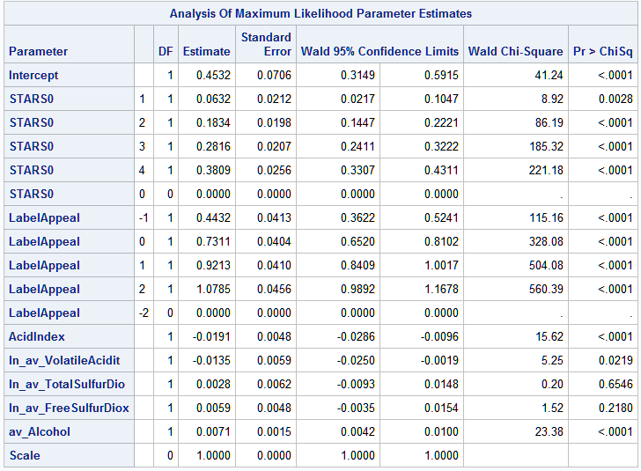

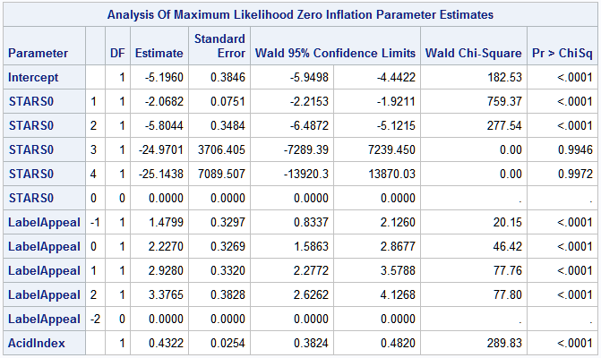

|  |  |  |  |  |
| --- | --- | --- | --- | --- |
| **Variable** | **Class** | **Estimate** | **exp(β)** | **exp(β)-1** |
| Intercept |  | -5.196 | 0.005539 | -0.99446 |
| STARS0 | 1 | -2.0682 | 0.126413 | -0.87359 |
| STARS0 | 2 | -5.8044 | 0.003014 | -0.99699 |
| STARS0 | 3 | -24.9701 | 1.43E-11 | -1 |
| STARS0 | 4 | -25.1438 | 1.2E-11 | -1 |
| STARS0 | 0 | 0 | 1 | 0 |
| LabelAppeal | -1 | 1.4799 | 4.392506 | 3.392506 |
| LabelAppeal | 0 | 2.227 | 9.272008 | 8.272008 |
| LabelAppeal | 1 | 2.928 | 18.69021 | 17.69021 |
| LabelAppeal | 2 | 3.3765 | 29.26815 | 28.26815 |
| LabelAppeal | -2 | 0 | 1 | 0 |
| AcidIndex |  | 0.4322 | 1.540643 | 0.540643 |

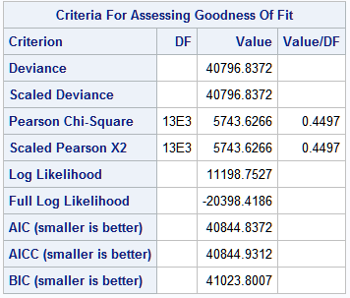

**Model 7:** **GENMOD with Zero Inflated Negative Binomial distribution and all quantitative variables**

The parameter estimates are the same as in model 5 but the Goodness of Fit criteria are different.

The following interpretations assume that all other variables are held constant.

* Assuming that all variables are zero, the logarithm of expected number of wine cases purchased would be 1.1244.
* If a wine increased its stars0 rating by 1 point, the logarithm of expected number of wine cases purchased would be expected to increase by 0.1013.
* If a wine increased its LabelAppeal score by 1 point, the logarithm of expected number of wine cases purchased would be expected to increase by 0.2332.
* If a wine increased its AcidIndex score by 1 point, the logarithm of expected number of wine cases purchased would be expected to decrease by 0.0187.
* If a wine increased its natural logarithm, absolute value transformed Volatile Acidity content by 1 unit, the logarithm of expected number of wine cases purchased would be expected to decrease by 0.0138.
* If a wine increased its natural logarithm, absolute value transformed Total Sulfur Dioxide content by 1 unit, the logarithm of expected number of wine cases purchased would be expected to increase by 0.0027.
* If a wine increased its natural logarithm, absolute value transformed Free Sulfur Dioxide rating by 1 unit, the logarithm of expected number of wine cases purchased would be expected to increase by 0.0062.
* If a wine increased it absolute value transformed alcohol content by 1 unit, the logarithm of expected number of wine cases purchased would be expected to increase by 0.0069.

For the zero inflated parameter estimates, assuming that all other variables are held constant:

* If all of the predictor variables in the model are evaluated at zero, the log odds of the predicted number of wine cases purchased being zero would be 0.050545.
* If a wine increased its STARS0 rating by 1 point, the odds of the expected number wine cases purchased being zero would decrease by a factor of 0.093462 and by 90.65%.
* If a wine increased its LabelAppeal score by 1 point, odds of the expected number wine cases purchased would increase by a factor of 2.048525 and by 104.85%.
* If a wine increased its AcidIndex score by 1 point, odds of the expected number wine cases purchased would increase by a factor of 1.547901 and by 54.79%.

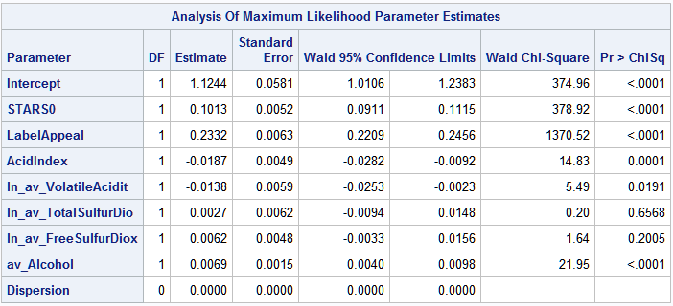

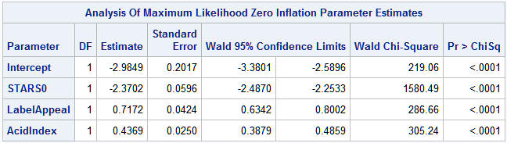

|  |  |  |  |
| --- | --- | --- | --- |
| **Variable** | **Estimate** | **exp(β)** | **exp(β)-1** |
| Intercept | -2.9849 | 0.050545 | -0.94946 |
| STARS0 | -2.3702 | 0.093462 | -0.90654 |
| LabelAppeal | 0.71712 | 2.048525 | 1.048525 |
| AcidIndex | 0.4369 | 1.547901 | 0.547901 |

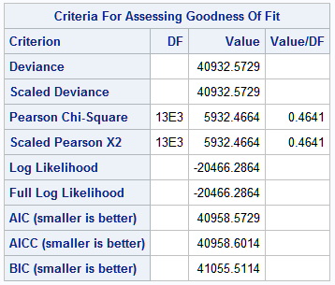

**Model 8: GENMOD with Zero Inflated Negative Binomial distribution and STARS0 and LabelAppeal as categorical variables**

The parameter estimates are the same as in model 6, but the Goodness of Fit criteria are different.

The following interpretations assume that all other variables are held constant.

* Assuming that all variables are zero (STARS0 at 0 and LabelAppeal at -2), the logarithm of expected number of wine cases purchased would be 0.4532.
* Given that STARS0 has a base level of 0 (lowest rating), we interpret obtaining a:
  + 1 rating: 0.0632 increase in the logarithm of expected number of cases purchased
  + 2 rating: 0.1834 increase in the logarithm of expected number of cases purchased
  + 3 rating: 0.2816 increase in the logarithm of expected number of cases purchased
  + 4 rating: 0.3809 increase in the logarithm of expected number of cases purchased
* Given that LabelAppeal has a base level of -2 (lowest rating), we interpret obtaining a:
  + -1 rating: 0.4432 increase in the logarithm of expected number of cases purchased
  + 0 rating: 0.7311 increase in the logarithm of expected number of cases purchased
  + +1 rating: 0.9213 increase in the logarithm of expected number of cases purchased
  + +2 rating: 1.0785 increase in the logarithm of expected number of cases purchased
* If a wine increased its AcidIndex score by 1 point, the logarithm of expected number of wine cases purchased would be expected to decrease by 0.0191.
* If a wine increased its natural logarithm, absolute value transformed Volatile Acidity content by 1 unit, the logarithm of expected number of wine cases purchased would be expected to decrease by 0.0135.
* If a wine increased its natural logarithm, absolute value transformed Total Sulfur Dioxide content by 1 unit, the logarithm of expected number of wine cases purchased would be expected to increase by 0.0028.
* If a wine increased its natural logarithm, absolute value transformed Free Sulfur Dioxide rating by 1 unit, the logarithm of expected number of wine cases purchased would be expected to increase by 0.0059.
* If a wine increased it absolute value transformed alcohol content by 1 unit, the logarithm of expected number of wine cases purchased would be expected to increase by 0.0071.

For the zero inflated parameter estimates, assuming that all other variables are held constant:

* If all of the predictor variables in the model are evaluated at zero, the log odds of the predicted number of wine cases purchased being zero would be 0.005539.
* Given that STARS0 has a base level of 0 (lowest rating), we interpret obtaining a:
  + 1 rating: decrease odds by a factor of 0.126413 and by 87.36% that the expected number of cases purchased will be zero.
  + 2 rating: decrease odds by a factor of 0.003014 and by 99.70% that the expected number of cases purchased will be zero.
  + 3 rating: decrease odds by a factor of 1.43e-11 and by 100% that the expected number of cases purchased will be zero.
  + 4 rating: decrease odds by a factor of 1.2e-11 and by 100% that the expected number of cases purchased will be zero.
* Given that LabelAppeal has a base level of -2 (lowest rating), we interpret obtaining a:
  + -1 rating: increase odds by a factor of 4.392506 and by 339.25% that the expected number of cases purchased will be zero.
  + 0 rating: increase odds by a factor of 9.272008 and by 827.20% that the expected number of cases purchased will be zero.
  + +1 rating: increase odds by a factor of 18.69021 and by 1769.02% that the expected number of cases purchased will be zero.
  + +2 rating: increase odds by a factor of 29.26815 and by 2826.82% that the expected number of cases purchased will be zero.
* If a wine increased its AcidIndex score by 1 point, the odds that the expected number wine cases purchased being zero would increase by a factor of 1.540643 and by 54.06%.

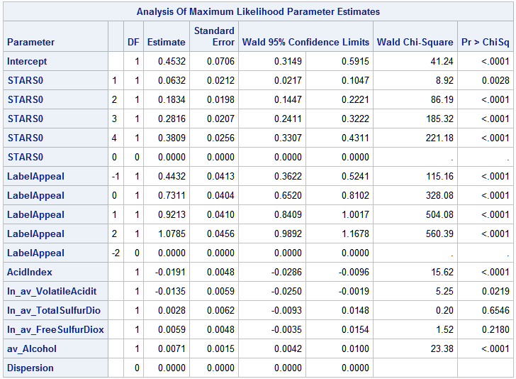

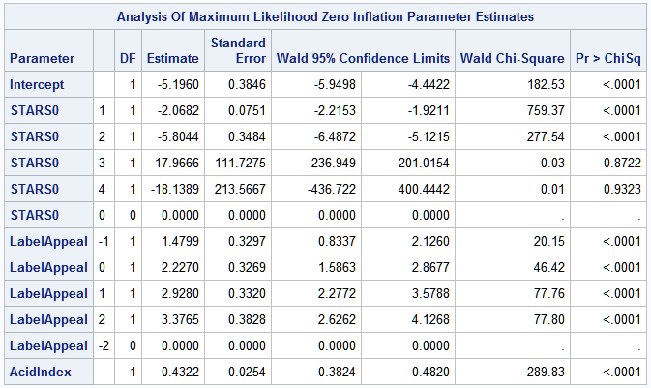

|  |  |  |  |  |
| --- | --- | --- | --- | --- |
| **Variable** | **Class** | **Estimate** | **exp(β)** | **exp(β)-1** |
| Intercept |  | -5.196 | 0.005539 | -0.99446 |
| STARS0 | 1 | -2.0682 | 0.126413 | -0.87359 |
| STARS0 | 2 | -5.8044 | 0.003014 | -0.99699 |
| STARS0 | 3 | -24.9701 | 1.43E-11 | -1 |
| STARS0 | 4 | -25.1438 | 1.2E-11 | -1 |
| STARS0 | 0 | 0 | 1 | 0 |
| LabelAppeal | -1 | 1.4799 | 4.392506 | 3.392506 |
| LabelAppeal | 0 | 2.227 | 9.272008 | 8.272008 |
| LabelAppeal | 1 | 2.928 | 18.69021 | 17.69021 |
| LabelAppeal | 2 | 3.3765 | 29.26815 | 28.26815 |
| LabelAppeal | -2 | 0 | 1 | 0 |
| AcidIndex |  | 0.4322 | 1.540643 | 0.540643 |

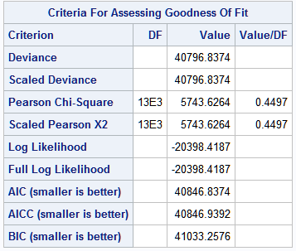

**Model 9: Linear Regression with all quantitative variables**

The following interpretations assume that all other variables are held constant.

* Assuming that all variables are zero, the expected number of wine cases purchased would be 2.3049.
* If a wine increased its stars0 rating by 1 point, the expected number of wine cases purchased would be expected to increase by 0.9767.
* If a wine increased its LabelAppeal score by 1 point, the expected number of wine cases purchased would be expected to increase by 0.43282.
* If a wine increased its AcidIndex score by 1 point, the expected number of wine cases purchased would be expected to decrease by 0.20192.
* If a wine increased its natural logarithm, absolute value transformed Volatile Acidity content by 1 unit, the expected number of wine cases purchased would be expected to decrease by 0.08599.
* If a wine increased its natural logarithm, absolute value transformed Total Sulfur Dioxide content by 1 unit, the expected number of wine cases purchased would be expected to increase by 0.08612.
* If a wine increased its natural logarithm, absolute value transformed Free Sulfur Dioxide rating by 1 unit, the expected number of wine cases purchased would be expected to increase by 0.04837.
* If a wine increased it absolute value transformed alcohol content by 1 unit, the expected number of wine cases purchased would be expected to increase by 0.01266.

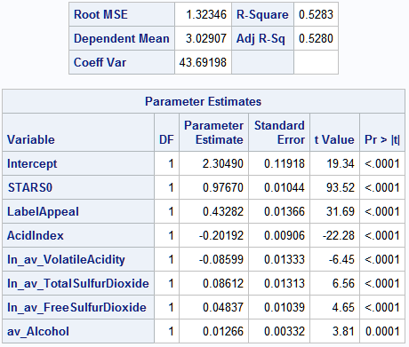

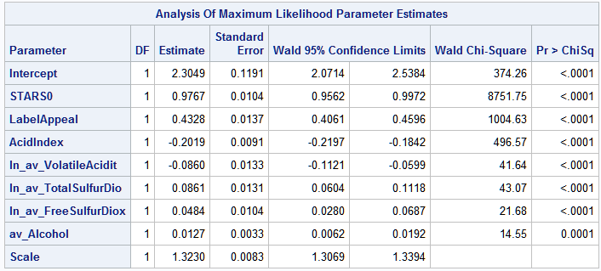

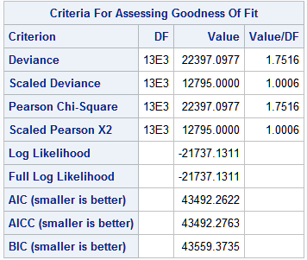

**Model 10: Linear Regression and STARS0 and LabelAppeal as categorical variables**

The following interpretations assume that all other variables are held constant.

* Assuming that all variables are zero (STARS0 at 0 and LabelAppeal at -2), the expected number of wine cases purchased would be 1.2300.
* Given that STARS0 has a base level of 0 (lowest rating), we interpret obtaining a:
  + 1 rating: 1.3677 increase in the expected number of cases purchased
  + 2 rating: 2.3944 increase in the expected number of cases purchased
  + 3 rating: 2.9659 increase in the expected number of cases purchased
  + 4 rating: 3.6576 increase in the expected number of cases purchased
* Given that LabelAppeal has a base level of -2 (lowest rating), we interpret obtaining a:
  + -1 rating: 0.3681 increase in the expected number of cases purchased
  + 0 rating: 0.8349 increase in the expected number of cases purchased
  + +1 rating: 1.2992 increase in the expected number of cases purchased
  + +2 rating: 1.8818 increase in the expected number of cases purchased
* If a wine increased its AcidIndex score by 1 point, the expected number of wine cases purchased would be expected to decrease by 0.1940.
* If a wine increased its natural logarithm, absolute value transformed Volatile Acidity content by 1 unit, the expected number of wine cases purchased would be expected to decrease by 0.0828.
* If a wine increased its natural logarithm, absolute value transformed Total Sulfur Dioxide content by 1 unit, the expected number of wine cases purchased would be expected to increase by 0.0786.
* If a wine increased its natural logarithm, absolute value transformed Free Sulfur Dioxide rating by 1 unit, the expected number of wine cases purchased would be expected to increase by 0.0441.
* If a wine increased it absolute value transformed alcohol content by 1 unit, the expected number of wine cases purchased would be expected to increase by 0.0143.

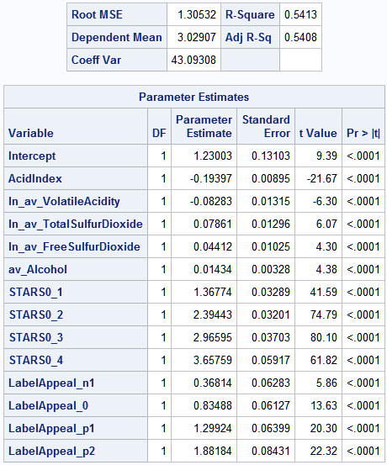

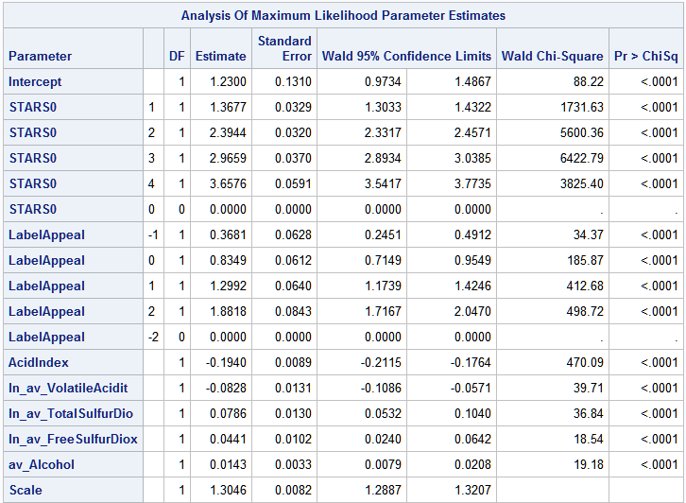

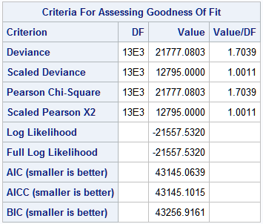

# 4. Select Models

As depicted in the previous section all parameter coefficients/estimates were very significant with p-values < 0.001 except for ln_av_VolatileAcidity, ln_av_TotalSulfurDioxide, ln_av_FreeTotalSulfurDioxide, and at times av_Alcohol. All models shared all 4 of these variables. All parameter coefficients signs (being positive or negative) were the same across all 10 models. The parameter coefficient signs were all intuitive. Both ln_av_VolatileAcidity and AcidIndex were negatively associated with TARGET while all of the other variables were positively associated with TARGET. Volatile Acidity is not desirable in wines and Acid Index may be a subjective rating of the acidity of the wine. If you think your wine tastes very acidic, then you probably will not enjoy the wine or order many cases of it.

The chart below details the metrics by which I can judge the 10 models with 7 variables. The odd number models utilize STARS0 and LabelAppeal as quantitative variables while the even number models utilize STARS0 and LabelAppeal as categorical variables. It appears that all of the even number models perform better on almost all metrics (overall lower deviance, lower log likelihood, lower AIC, lower AICC, lower BIC, higher R-Squared, and higher Adjusted R-Squared values) than their odd number model counterparts. The only metric that is not consistently better is the Pearson Chi Square test statistic that tests that at least one of the predictors' regression coefficient is not equal to zero (so you would want a large Chi Square statistic), however this measure may not be an appropriate to compare against other models. Furthermore, model 10 has higher R-Squared and Adjusted R-Squared values than model 9 meaning that model 10 is a better fitting model to the data in predicting TARGET than model 9. For these reasons, I will choose between only even number models (models with STARS0 and LabelAppeal as categorical variables).

Of the all of the even number models, Model 6 performs the best because it has the lowest AIC, AICC, and BIC values. Model 6 does have very high deviance and log likelihood values, however, deviance and log likelihood are terms that make up the AIC, AICC, and BICC formulas. Deviance and log likelihood are used to calculate AIC, AICC, and BIC. Therefore, keeping AIC, AICC, and BIC low are ultimately more important than keeping deviance and log likelihood lower.

|  |  |  |  |  |  |  |  |  |  |
| --- | --- | --- | --- | --- | --- | --- | --- | --- | --- |
| **Model** | **Description** | **Deviance** | **Pearson**  **Chi Square** | **Log Likelihood** | **AIC** | **AICC** | **BIC** | **R Squared** | **Adjusted R Squared** |
| **Model 1** | Poisson with all quantitative variables | 14720.1931 | 10885.0897 | 8266.0639 | 46678.2148 | 46678.2261 | 46678.8693 |  |  |
| **Model 2** | Poisson with 2 categorical variables | 13634.8913 | 11256.6553 | 8808.7148 | 45604.9130 | 45604.9459 | 45709.3084 |  |  |
| **Model 3** | Negative Binomial with all quantitative variables | 14720.1931 | 10885.0766 | 8266.0639 | 46680.2148 | 46680.2289 | 46747.3261 |  |  |
| **Model 4** | Negative Binomial with 2 categorical variables | 13634.8913 | 11256.6463 | 8808.7148 | 45606.9130 | 45606.9506 | 45718.7652 |  |  |
| **Model 5** | Zero Inflated Poisson with all quantitative variables | 40932.5745 | 5932.4742 | 11130.8840 | 40956.5745 | 40956.5989 | 41046.0563 |  |  |
| **Model 6** | Zero Inflated Poisson with 2 categorical variables | 40796.8372 | 5743.6266 | 11198.7527 | 40844.8372 | 40844.9312 | 41023.8007 |  |  |
| **Model 7** | Zero Inflated Negative Binomial with all quantitative variables | 40932.5729 | 5932.4664 | -20466.2864 | 40958.5729 | 40958.6014 | 41055.5114 |  |  |
| **Model 8** | Zero Inflated Negative Binomial with 2 categorical variables | 40796.8374 | 5743.6264 | -20398.4187 | 40846.8374 | 40846.9392 | 41033.2573 |  |  |
| **Model 9** | Regression with all quantitative variables | 22397.0977 | 22397.0977 | -21737.1311 | 43492.2622 | 42492.2763 | 43559.3735 | 0.5283 | 0.5280 |
| **Model 10** | Regression with 2 categorical variables | 21777.0803 | 21777.0803 | -21557.5320 | 43145.0639 | 43145.1015 | 43256.9161 | 0.5413 | 0.5408 |

The following matrix displays the first 20 observations of the wine training data set and the predicted values from each of the models. The bottom 2 rows of the table show the sum of absolute error and sum of squared error between the actual and predicted values. In even just the first 20 observations, model 6 is one of the top performing models with only a very miniscule difference with the best performing model.

|  |  |  |  |  |  |  |  |  |  |  |  |
| --- | --- | --- | --- | --- | --- | --- | --- | --- | --- | --- | --- |
|  | **Actual Values** | **Predicted Values** | | | | | | | | | |
| **Obs** | **TARGET** | **model 1** | **model 2** | **model 3** | **model 4** | **model 5** | **model 6** | **model 7** | **model 8** | **model 9** | **model 10** |
| 1 | 3 | 3.06226 | 3.59694 | 3.06233 | 3.59694 | 3.54087 | 3.72045 | 3.54574 | 3.72045 | 3.40289 | 3.62811 |
| 2 | 3 | 4.09676 | 3.81408 | 4.20177 | 3.81408 | 3.29729 | 3.23896 | 3.29993 | 3.23896 | 4.30877 | 4.08321 |
| 3 | 5 | 3.65228 | 3.50689 | 3.74897 | 3.50689 | 3.42613 | 3.36562 | 3.42051 | 3.36562 | 4.06825 | 3.87384 |
| 4 | 3 | 2.28121 | 2.49443 | 2.2948 | 2.49443 | 2.55218 | 2.44195 | 2.55264 | 2.44195 | 2.356 | 2.47948 |
| 5 | 4 | 2.92057 | 3.49763 | 2.94997 | 3.49763 | 3.6354 | 3.83237 | 3.63521 | 3.83237 | 3.36061 | 3.59585 |
| 6 | 0 | 1.20486 | 0.94309 | 1.21933 | 0.94309 | 0.41385 | 0.44358 | 0.4062 | 0.44358 | 0.78463 | 0.61874 |
| 7 | 0 | 1.73359 | 1.28879 | 1.75234 | 1.28879 | 1.15509 | 1.2233 | 1.14013 | 1.2233 | 1.63505 | 1.41012 |
| 8 | 4 | 6.11354 | 5.37871 | 5.63827 | 5.37871 | 5.27774 | 5.24074 | 5.2702 | 5.24074 | 5.23051 | 5.0597 |
| 9 | 3 | 2.05234 | 1.52119 | 2.07788 | 1.52119 | 1.93526 | 2.04596 | 1.91951 | 2.04596 | 2.06804 | 1.83806 |
| 10 | 6 | 6.00909 | 4.84611 | 6.03422 | 4.84611 | 4.60285 | 4.76294 | 4.60576 | 4.76294 | 5.53294 | 5.06722 |
| 11 | 0 | 3.42439 | 3.93435 | 3.42912 | 3.93435 | 4.17753 | 3.99584 | 4.19008 | 3.99584 | 3.59172 | 3.77587 |
| 12 | 4 | 2.63702 | 3.19075 | 2.68596 | 3.19075 | 3.43263 | 3.64193 | 3.4303 | 3.64193 | 3.11843 | 3.35719 |
| 13 | 3 | 3.76596 | 4.38974 | 3.7999 | 4.38974 | 4.38695 | 4.41992 | 4.38735 | 4.41992 | 4.01136 | 4.25125 |
| 14 | 7 | 5.4369 | 5.38502 | 5.49798 | 5.38502 | 6.48342 | 6.00023 | 6.48553 | 6.00023 | 5.29292 | 5.30156 |
| 15 | 4 | 1.47016 | 1.11197 | 1.47469 | 1.11197 | 0.81273 | 0.89109 | 0.82551 | 0.89109 | 1.21481 | 1.01949 |
| 16 | 0 | 1.74446 | 1.27445 | 1.74634 | 1.27445 | 1.09054 | 1.18559 | 1.10554 | 1.18559 | 1.5988 | 1.36493 |
| 17 | 0 | 1.7193 | 1.26895 | 1.71904 | 1.26895 | 0.54131 | 0.58682 | 0.55885 | 0.58682 | 1.64647 | 1.45928 |
| 18 | 4 | 4.39497 | 4.30964 | 4.47374 | 4.30964 | 4.09348 | 4.24621 | 4.09568 | 4.24621 | 4.57221 | 4.3829 |
| 19 | 5 | 2.8845 | 3.49121 | 2.9344 | 3.49121 | 4.03797 | 4.28815 | 4.02729 | 4.28815 | 3.4569 | 3.72776 |
| 20 | 4 | 2.92664 | 3.26974 | 2.93771 | 3.26974 | 3.06003 | 3.02866 | 3.05953 | 3.02866 | 3.25899 | 3.45232 |
| 21 | 3 | 2.42094 | 2.62604 | 2.41631 | 2.62604 | 2.64446 | 2.53758 | 2.64995 | 2.53758 | 2.50741 | 2.62918 |
| 22 | 2 | 2.06254 | 2.31568 | 2.09593 | 2.31568 | 2.53355 | 2.41183 | 2.53169 | 2.41183 | 2.16574 | 2.30825 |
| 23 | 3 | 2.22555 | 2.60164 | 2.22277 | 2.60164 | 2.76274 | 2.74526 | 2.80961 | 2.74526 | 2.404 | 2.58083 |
| 24 | 4 | 1.93581 | 1.42797 | 1.94934 | 1.42797 | 0.84944 | 0.87861 | 0.84219 | 0.87861 | 1.97605 | 1.77844 |
| 25 | 4 | 3.51357 | 4.14991 | 3.59469 | 4.14991 | 3.7535 | 3.92394 | 3.75583 | 3.92394 | 3.81792 | 4.02264 |
| 26 | 0 | 1.6517 | 1.0878 | 1.54274 | 1.0878 | 1.77059 | 1.64863 | 1.61546 | 1.64863 | 1.21574 | 0.97361 |
| 27 | 4 | 3.60019 | 4.28368 | 3.65739 | 4.28368 | 4.43407 | 4.50505 | 4.46608 | 4.50505 | 3.92438 | 4.17804 |
| 28 | 6 | 7.83912 | 5.50281 | 6.81312 | 5.50281 | 5.72645 | 5.67084 | 5.71621 | 5.67084 | 5.89719 | 5.46931 |
| 29 | 4 | 2.86825 | 3.76407 | 3.1766 | 3.76407 | 3.83095 | 4.04721 | 3.83879 | 4.04721 | 3.60279 | 3.84021 |
| 30 | 3 | 1.97024 | 2.22539 | 1.98723 | 2.22539 | 2.54572 | 2.41082 | 2.54567 | 2.41082 | 2.07664 | 2.23271 |
| **Sum of Absolute Error** | | 37.02637 | 32.57295 | 34.9215 | 32.57295 | 29.621 | 29.44818 | 29.49289 | 29.44818 | 31.22962 | 30.2732 |
| **Sum of Squared Error** | | 63.37203 | 56.08298 | 57.27475 | 56.08298 | 56.92556 | 54.92481 | 56.54066 | 54.92481 | 50.61291 | 50.26625 |

**The Best Model is Model 6: GENMOD with Zero Inflated Poisson distribution and STARS0 and LabelAppeal as categorical variables**

The following interpretations assume that all other variables are held constant.

* Assuming that all variables are zero (STARS0 at 0 and LabelAppeal at -2), the logarithm of expected number of wine cases purchased would be 0.4532.
* Given that STARS0 has a base level of 0 (lowest rating), we interpret obtaining a:
  + 1 rating: 0.0632 increase in the logarithm of expected number of cases purchased
  + 2 rating: 0.1834 increase in the logarithm of expected number of cases purchased
  + 3 rating: 0.2816 increase in the logarithm of expected number of cases purchased
  + 4 rating: 0.3809 increase in the logarithm of expected number of cases purchased
* Given that LabelAppeal has a base level of -2 (lowest rating), we interpret obtaining a:
  + -1 rating: 0.4432 increase in the logarithm of expected number of cases purchased
  + 0 rating: 0.7311 increase in the logarithm of expected number of cases purchased
  + +1 rating: 0.9213 increase in the logarithm of expected number of cases purchased
  + +2 rating: 1.0785 increase in the logarithm of expected number of cases purchased
* If a wine increased its AcidIndex score by 1 point, the logarithm of expected number of wine cases purchased would be expected to decrease by 0.0191.
* If a wine increased its natural logarithm, absolute value transformed Volatile Acidity content by 1 unit, the logarithm of expected number of wine cases purchased would be expected to decrease by 0.0135.
* If a wine increased its natural logarithm, absolute value transformed Total Sulfur Dioxide content by 1 unit, the logarithm of expected number of wine cases purchased would be expected to increase by 0.0028.
* If a wine increased its natural logarithm, absolute value transformed Free Sulfur Dioxide rating by 1 unit, the logarithm of expected number of wine cases purchased would be expected to increase by 0.0059.
* If a wine increased it absolute value transformed alcohol content by 1 unit, the logarithm of expected number of wine cases purchased would be expected to increase by 0.0071.

For the zero inflated parameter estimates, assuming that all other variables are held constant:

* If all of the predictor variables in the model are evaluated at zero, the log odds of the predicted number of wine cases purchased being zero would be 0.005539.
* Given that STARS0 has a base level of 0 (lowest rating), we interpret obtaining a:
  + 1 rating: decrease odds by a factor of 0.126413 and by 87.36% that the expected number of cases purchased will be zero.
  + 2 rating: decrease odds by a factor of 0.003014 and by 99.70% that the expected number of cases purchased will be zero.
  + 3 rating: decrease odds by a factor of 1.43e-11 and by 100% that the expected number of cases purchased will be zero.
  + 4 rating: decrease odds by a factor of 1.2e-11 and by 100% that the expected number of cases purchased will be zero.
* Given that LabelAppeal has a base level of -2 (lowest rating), we interpret obtaining a:
  + -1 rating: increase odds by a factor of 4.392506 and by 339.25% that the expected number of cases purchased will be zero.
  + 0 rating: increase odds by a factor of 9.272008 and by 827.20% that the expected number of cases purchased will be zero.
  + +1 rating: increase odds by a factor of 18.69021 and by 1769.02% that the expected number of cases purchased will be zero.
  + +2 rating: increase odds by a factor of 29.26815 and by 2826.82% that the expected number of cases purchased will be zero.
* If a wine increased its AcidIndex score by 1 point, the odds that the expected number wine cases purchased being zero would increase by a factor of 1.540643 and by 54.06%.





|  |  |  |  |  |
| --- | --- | --- | --- | --- |
| **Variable** | **Class** | **Estimate** | **exp(β)** | **exp(β)-1** |
| Intercept |  | -5.196 | 0.005539 | -0.99446 |
| STARS0 | 1 | -2.0682 | 0.126413 | -0.87359 |
| STARS0 | 2 | -5.8044 | 0.003014 | -0.99699 |
| STARS0 | 3 | -24.9701 | 1.43E-11 | -1 |
| STARS0 | 4 | -25.1438 | 1.2E-11 | -1 |
| STARS0 | 0 | 0 | 1 | 0 |
| LabelAppeal | -1 | 1.4799 | 4.392506 | 3.392506 |
| LabelAppeal | 0 | 2.227 | 9.272008 | 8.272008 |
| LabelAppeal | 1 | 2.928 | 18.69021 | 17.69021 |
| LabelAppeal | 2 | 3.3765 | 29.26815 | 28.26815 |
| LabelAppeal | -2 | 0 | 1 | 0 |
| AcidIndex |  | 0.4322 | 1.540643 | 0.540643 |



# 5. Model Deployment

The purpose of this assignment was to develop a model to predict the number of cases of wine that will be sold given certain properties of the wine. The wine training data set contained 12,795 observations and 14 variables. Two of the variables were subjective variables which I utilized as both quantitative and categorical variables during the modeling process. There were 12 continuous variables related to the chemical properties of the wine being sold. There were 2 numerical variables for the marketing score based on the visual appeal of the label and wine rating based on number of stars. The target variable is the number of sample cases of wine that were purchased by wine distribution companies after sampling a wine. These cases would be used to provide tasting samples to restaurants and wine stores around the United States. The more sample cases purchased, the more likely a wine is to be sold at a high end restaurant. If it is possible to predict the number of cases, the wine manufacturer will be able to adjust their wine offerings with the goal to maximize sales. The purpose of this project was to build a model to predict the number of cases of wine that will be sold given certain properties of the wine. I built several Poisson and Negative Binomial distribution models to predict the target number of cases ordered for each wine. I compared 10 models of 7 variables each and found that the best model was a Zero Inflated Poisson distribution model with the STARS0 and LabelAppeal variables used as categorical variables.

**Model 6:** **Zero Inflated Poisson distribution and STARS0 and LabelAppeal as categorical variables**

TEMP = **0.4532**

+ AcidIndex * -**0.0632**

+ ln_av_VolatileAcidity * -**0.0135**

+ ln_av_TotalSulfurDioxide * **0.0028**

+ ln_av_FreeSulfurDioxide * **0.0059**

+ av_Alcohol * **0.0071**

+ (stars0 in ("1")) * **0.0632**

+ (stars0 in ("2")) * **0.1834**

+ (stars0 in ("3")) * **0.2816**

+ (stars0 in ("4")) * **0.3809**

+ (LabelAppeal in ("-1")) * **0.4432**

+ (LabelAppeal in ("0")) * **0.7311**

+ (LabelAppeal in ("1")) * **0.9213**

+ (LabelAppeal in ("2")) * **1.0785**;

P_SCORE_ZIP_ALL = exp(TEMP);

TEMP = -**5.1960**

+ AcidIndex * **0.4322**

+ (stars0 in ("1")) * -**2.0682**

+ (stars0 in ("2")) * -**5.8044**

+ (stars0 in ("3")) * -**24.9701**

+ (stars0 in ("4")) * -**25.1438**

+ (LabelAppeal in ("-1")) * **1.4799**

+ (LabelAppeal in ("0")) * **2.2270**

+ (LabelAppeal in ("1")) * **2.9280**

+ (LabelAppeal in ("2")) * **3.3765**;

P_SCORE_ZERO = exp(TEMP)/(**1**+exp(TEMP));

P_TARGET = P_SCORE_ZIP_ALL * (**1**-P_SCORE_ZERO);

In order to use this model, please open the SAS program. Then, place “wine.sas7bdat” and “wine_test.sas7bdat” in the temporary working directory that is created after SAS is opened. Next, open the following SAS script file (“Joshua Peng Deploy Model.sas”) and run the script. The model predicted values computed with PROC GENMOD are stored in an output variable called “m6”.

The following is my SAS data step code for model deployment which creates a scored data file. After loading in the training and test data sets, the second portion of the code runs through all of the data transformation steps including imputing missing values, adding transformed variables, adding dummy variables, and adding indicator variables. Next, a data step uses the best model on the wine_test holdout test data set to generate predicted values listed under the variable “P_TARGET”. The same code below is in a data file entitled “Joshua Peng Deploy Model.sas.”

“Joshua Peng Deploy Model.sas”

* Loading in data;

**data** test; set wine_test;

* Imputing missing observations with mean value and adding new variables in test set;

**data** test0; set test;

if missing(Alcohol) then alcohol = **10.4892363**;

if missing(FreeSulfurDioxide) then FreeSulfurDioxide = **30.8455713**;

stars0 = stars;

if missing(stars) then stars0 = **0**;

if missing(TotalSulfurDioxide) then TotalSulfurDioxide = **120.7142326**;

av_Alcohol = abs(Alcohol);

av_VolatileAcidity = abs(VolatileAcidity);

av_FreeSulfurDioxide = abs(FreeSulfurDioxide);

av_TotalSulfurDioxide = abs(TotalSulfurDioxide);

if av_VolatileAcidity = **0** then ln_av_VolatileAcidity = **0**;

else ln_av_VolatileAcidity = log(av_VolatileAcidity);

if av_FreeSulfurDioxide = **0** then ln_av_FreeSulfurDioxide = **0**;

else ln_av_FreeSulfurDioxide = log(av_FreeSulfurDioxide);

if av_TotalSulfurDioxide = **0** then ln_av_TotalSulfurDioxide = **0**;

else ln_av_TotalSulfurDioxide = log(av_TotalSulfurDioxide);

**run**;

* Score test data with SAS data step;

**data** testscore; set test0;

TEMP = **0.4532**

+ AcidIndex * -**0.0632**

+ ln_av_VolatileAcidity * -**0.0135**

+ ln_av_TotalSulfurDioxide * **0.0028**

+ ln_av_FreeSulfurDioxide * **0.0059**

+ av_Alcohol * **0.0071**

+ (stars0 in (**1**)) * **0.0632**

+ (stars0 in (**2**)) * **0.1834**

+ (stars0 in (**3**)) * **0.2816**

+ (stars0 in (**4**)) * **0.3809**

+ (LabelAppeal in (-**1**)) * **0.4432**

+ (LabelAppeal in (**0**)) * **0.7311**

+ (LabelAppeal in (**1**)) * **0.9213**

+ (LabelAppeal in (**2**)) * **1.0785**;

P_SCORE_ZIP_ALL = exp(TEMP);

TEMP = -**5.1960**

+ AcidIndex * **0.4322**

+ (stars0 in (**1**)) * -**2.0682**

+ (stars0 in (**2**)) * -**5.8044**

+ (stars0 in (**3**)) * -**24.9701**

+ (stars0 in (**4**)) * -**25.1438**

+ (LabelAppeal in (-**1**)) * **1.4799**

+ (LabelAppeal in (**0**)) * **2.2270**

+ (LabelAppeal in (**1**)) * **2.9280**

+ (LabelAppeal in (**2**)) * **3.3765**;

P_SCORE_ZERO = exp(TEMP)/(**1**+exp(TEMP));

P_TARGET = P_SCORE_ZIP_ALL * (**1**-P_SCORE_ZERO);

keep INDEX P_TARGET;

**run**;

If you want to generate the predicted values from models 2 (POI), 4 (NB), 6 (ZIP), 8 (ZINB), and 10 (REG) and have them merged in the same output file then you can run “Joshua Peng Deploy Model Merged.sas.”

* Loading in data;

**data** test; set wine_test;

* Imputing missing observations with mean value and adding new variables in test set;

**data** test0; set test;

if missing(Alcohol) then alcohol = **10.4892363**;

if missing(FreeSulfurDioxide) then FreeSulfurDioxide = **30.8455713**;

stars0 = stars;

if missing(stars) then stars0 = **0**;

if missing(TotalSulfurDioxide) then TotalSulfurDioxide = **120.7142326**;

av_Alcohol = abs(Alcohol);

av_VolatileAcidity = abs(VolatileAcidity);

av_FreeSulfurDioxide = abs(FreeSulfurDioxide);

av_TotalSulfurDioxide = abs(TotalSulfurDioxide);

if av_VolatileAcidity = **0** then ln_av_VolatileAcidity = **0**;

else ln_av_VolatileAcidity = log(av_VolatileAcidity);

if av_FreeSulfurDioxide = **0** then ln_av_FreeSulfurDioxide = **0**;

else ln_av_FreeSulfurDioxide = log(av_FreeSulfurDioxide);

if av_TotalSulfurDioxide = **0** then ln_av_TotalSulfurDioxide = **0**;

else ln_av_TotalSulfurDioxide = log(av_TotalSulfurDioxide);

* Variable of reference: 0;

if STARS0 in (**0** **1** **2** **3** **4**) then do;

STARS0_1 = (STARS0 eq **1**);

STARS0_2 = (STARS0 eq **2**);

STARS0_3 = (STARS0 eq **3**);

STARS0_4 = (STARS0 eq **4**);

end;

* Variable of reference: -2;

if LabelAppeal in (-**2** -**1** **0** **1** **2**) then do;

LabelAppeal_n1 = (LabelAppeal eq -**1**);

LabelAppeal_0 = (LabelAppeal eq **0**);

LabelAppeal_p1 = (LabelAppeal eq **1**);

LabelAppeal_p2 = (LabelAppeal eq **2**);

end;

**run**;

* Score test data (POI Model 2) with SAS data step;

**data** testscore_poi; set test0;

TEMP = **0.1413**

+ AcidIndex * -**0.0778**

+ ln_av_VolatileAcidity * -**0.0262**

+ ln_av_TotalSulfurDioxide * **0.0283**

+ ln_av_FreeSulfurDioxide * **0.0156**

+ av_Alcohol * **0.0043**

+ (stars0 in (**1**)) * **0.7676**

+ (stars0 in (**2**)) * **1.0838**

+ (stars0 in (**3**)) * **1.2051**

+ (stars0 in (**4**)) * **1.3272**

+ (LabelAppeal in (-**1**)) * **0.2381**

+ (LabelAppeal in (**0**)) * **0.4274**

+ (LabelAppeal in (**1**)) * **0.5602**

+ (LabelAppeal in (**2**)) * **0.6962**;

P_TARGET_POI = exp(TEMP);

keep INDEX P_TARGET_POI;

**run**;

* Score test data (NB Model 4) with SAS data step;

**data** testscore_nb; set test0;

TEMP = **0.1413**

+ AcidIndex * -**0.0778**

+ ln_av_VolatileAcidity * -**0.0262**

+ ln_av_TotalSulfurDioxide * **0.0283**

+ ln_av_FreeSulfurDioxide * **0.0156**

+ av_Alcohol * **0.0043**

+ (stars0 in (**1**)) * **0.7676**

+ (stars0 in (**2**)) * **1.0838**

+ (stars0 in (**3**)) * **1.2051**

+ (stars0 in (**4**)) * **1.3272**

+ (LabelAppeal in (-**1**)) * **0.2381**

+ (LabelAppeal in (**0**)) * **0.4274**

+ (LabelAppeal in (**1**)) * **0.5602**

+ (LabelAppeal in (**2**)) * **0.6962**;

P_TARGET_NB = exp(TEMP);

keep INDEX P_TARGET_NB;

**run**;

* Score test data (ZIP Model 6) with SAS data step;

**data** testscore_zip; set test0;

TEMP = **0.4532**

+ AcidIndex * -**0.0632**

+ ln_av_VolatileAcidity * -**0.0135**

+ ln_av_TotalSulfurDioxide * **0.0028**

+ ln_av_FreeSulfurDioxide * **0.0059**

+ av_Alcohol * **0.0071**

+ (stars0 in (**1**)) * **0.0632**

+ (stars0 in (**2**)) * **0.1834**

+ (stars0 in (**3**)) * **0.2816**

+ (stars0 in (**4**)) * **0.3809**

+ (LabelAppeal in (-**1**)) * **0.4432**

+ (LabelAppeal in (**0**)) * **0.7311**

+ (LabelAppeal in (**1**)) * **0.9213**

+ (LabelAppeal in (**2**)) * **1.0785**;

P_SCORE_ZIP_ALL = exp(TEMP);

TEMP = -**5.1960**

+ AcidIndex * **0.4322**

+ (stars0 in (**1**)) * -**2.0682**

+ (stars0 in (**2**)) * -**5.8044**

+ (stars0 in (**3**)) * -**24.9701**

+ (stars0 in (**4**)) * -**25.1438**

+ (LabelAppeal in (-**1**)) * **1.4799**

+ (LabelAppeal in (**0**)) * **2.2270**

+ (LabelAppeal in (**1**)) * **2.9280**

+ (LabelAppeal in (**2**)) * **3.3765**;

P_SCORE_ZERO = exp(TEMP)/(**1**+exp(TEMP));

P_TARGET_ZIP = P_SCORE_ZIP_ALL * (**1**-P_SCORE_ZERO);

keep INDEX P_TARGET_ZIP;

**run**;

* Score test data (ZINB Model 8) with SAS data step;

**data** testscore_zinb; set test0;

TEMP = **0.4532**

+ AcidIndex * -**0.0632**

+ ln_av_VolatileAcidity * -**0.0135**

+ ln_av_TotalSulfurDioxide * **0.0028**

+ ln_av_FreeSulfurDioxide * **0.0059**

+ av_Alcohol * **0.0071**

+ (stars0 in (**1**)) * **0.0632**

+ (stars0 in (**2**)) * **0.1834**

+ (stars0 in (**3**)) * **0.2816**

+ (stars0 in (**4**)) * **0.3809**

+ (LabelAppeal in (-**1**)) * **0.4432**

+ (LabelAppeal in (**0**)) * **0.7311**

+ (LabelAppeal in (**1**)) * **0.9213**

+ (LabelAppeal in (**2**)) * **1.0785**;

P_SCORE_ZINB_ALL = exp(TEMP);

TEMP = -**5.1960**

+ AcidIndex * **0.4322**

+ (stars0 in (**1**)) * -**2.0682**

+ (stars0 in (**2**)) * -**5.8044**

+ (stars0 in (**3**)) * -**24.9701**

+ (stars0 in (**4**)) * -**25.1438**

+ (LabelAppeal in (-**1**)) * **1.4799**

+ (LabelAppeal in (**0**)) * **2.2270**

+ (LabelAppeal in (**1**)) * **2.9280**

+ (LabelAppeal in (**2**)) * **3.3765**;

P_SCORE_ZERO = exp(TEMP)/(**1**+exp(TEMP));

P_TARGET_ZINB = P_SCORE_ZINB_ALL * (**1**-P_SCORE_ZERO);

keep INDEX P_TARGET_ZINB;

**run**;

* Score test data (REG Model 10) with SAS data step;

**data** testscore_reg; set test0;

P_TARGET_REG = **1.23003**

+ AcidIndex * -**0.19397**

+ ln_av_VolatileAcidity * -**0.08283**

+ ln_av_TotalSulfurDioxide * **0.07861**

+ ln_av_FreeSulfurDioxide * **0.04412**

+ av_Alcohol * **0.01434**

+ stars0_1 * **1.36774**

+ stars0_2 * **2.39443**

+ stars0_3 * **2.96595**

+ stars0_4 * **3.65759**

+ LabelAppeal_n1 * **0.36814**

+ LabelAppeal_0 * **0.83488**

+ LabelAppeal_p1 * **1.29924**

+ LabelAppeal_p2 * **1.88184**;

keep INDEX P_TARGET_REG;

**run**;

* Score test data (ZIP with Cloglog link Model 11) with SAS data step;

**data** testscore_zip11; set test0;

TEMP = **0.4636**

+ AcidIndex * -**0.0209**

+ ln_av_VolatileAcidity * -**0.0135**

+ ln_av_TotalSulfurDioxide * **0.0028**

+ ln_av_FreeSulfurDioxide * **0.0060**

+ av_Alcohol * **0.0071**

+ (stars0 in (**1**)) * **0.0688**

+ (stars0 in (**2**)) * **0.1853**

+ (stars0 in (**3**)) * **0.2838**

+ (stars0 in (**4**)) * **0.3833**

+ (LabelAppeal in (-**1**)) * **0.4450**

+ (LabelAppeal in (**0**)) * **0.7311**

+ (LabelAppeal in (**1**)) * **0.9209**

+ (LabelAppeal in (**2**)) * **1.0777**;

P_SCORE_ZIP_ALL = exp(TEMP);

TEMP = -**4.0081**

+ AcidIndex * **0.2687**

+ (stars0 in (**1**)) * -**1.5432**

+ (stars0 in (**2**)) * -**5.1362**

+ (stars0 in (**3**)) * -**24.0085**

+ (stars0 in (**4**)) * -**25.1524**

+ (LabelAppeal in (-**1**)) * **1.2427**

+ (LabelAppeal in (**0**)) * **1.7738**

+ (LabelAppeal in (**1**)) * **2.2531**

+ (LabelAppeal in (**2**)) * **2.4212**;

P_SCORE_ZERO = exp(TEMP)/(**1**+exp(TEMP));

P_TARGET_ZIP = P_SCORE_ZIP_ALL * (**1**-P_SCORE_ZERO);

keep INDEX P_TARGET_ZIP;

**run**;

* Score test data (ZIP with Probit link Model 12) with SAS data step;

**data** testscore_zip12; set test0;

TEMP = **0.4502**

+ AcidIndex * -**0.0189**

+ ln_av_VolatileAcidity * -**0.0135**

+ ln_av_TotalSulfurDioxide * **0.0029**

+ ln_av_FreeSulfurDioxide * **0.0060**

+ av_Alcohol * **0.0071**

+ (stars0 in (**1**)) * **0.0608**

+ (stars0 in (**2**)) * **0.1819**

+ (stars0 in (**3**)) * **0.2804**

+ (stars0 in (**4**)) * **0.3797**

+ (LabelAppeal in (-**1**)) * **0.4439**

+ (LabelAppeal in (**0**)) * **0.7329**

+ (LabelAppeal in (**1**)) * **0.9233**

+ (LabelAppeal in (**2**)) * **1.0807**;

P_SCORE_ZIP_ALL = exp(TEMP);

TEMP = -**3.0205**

+ AcidIndex * **0.2501**

+ (stars0 in (**1**)) * -**1.2351**

+ (stars0 in (**2**)) * -**3.0271**

+ (stars0 in (**3**)) * -**5.8146**

+ (stars0 in (**4**)) * -**5.5576**

+ (LabelAppeal in (-**1**)) * **0.8673**

+ (LabelAppeal in (**0**)) * **1.3150**

+ (LabelAppeal in (**1**)) * **1.7290**

+ (LabelAppeal in (**2**)) * **1.9903**;

P_SCORE_ZERO = exp(TEMP)/(**1**+exp(TEMP));

P_TARGET_ZIP = P_SCORE_ZIP_ALL * (**1**-P_SCORE_ZERO);

keep INDEX P_TARGET_ZIP;

**run**;

*///merge all of the model results together///;

**data** testscore;

merge testscore_poi(in=ina) testscore_nb(in=inb)

testscore_zip testscore_zinb testscore_reg;

by INDEX;

if ina;

**run**;

*///final datastep to retain index and model results///;

**data** testscore;

set testscore;

keep index p_target_poi p_target_nb p_target_zip p_target_zinb p_target_reg;

**run**;

# 6. Bonus

**Model 11: GENMOD with Zero Inflated Poisson distribution (zeromodel using complementary log-log link) and STARS0 and LabelAppeal as categorical variables**

The following interpretations assume that all other variables are held constant.

* Assuming that all variables are zero (STARS0 at 0 and LabelAppeal at -2), the logarithm of expected number of wine cases purchased would be 0.4636.
* Given that STARS0 has a base level of 0 (lowest rating), we interpret obtaining a:
  + 1 rating: 0.0688 increase in the logarithm of expected number of cases purchased
  + 2 rating: 0.1853 increase in the logarithm of expected number of cases purchased
  + 3 rating: 0.2838 increase in the logarithm of expected number of cases purchased
  + 4 rating: 0.3833 increase in the logarithm of expected number of cases purchased
* Given that LabelAppeal has a base level of -2 (lowest rating), we interpret obtaining a:
  + -1 rating: 0.4450 increase in the logarithm of expected number of cases purchased
  + 0 rating: 0.7311 increase in the logarithm of expected number of cases purchased
  + +1 rating: 0.9209 increase in the logarithm of expected number of cases purchased
  + +2 rating: 1.0777 increase in the logarithm of expected number of cases purchased
* If a wine increased its AcidIndex score by 1 point, the logarithm of expected number of wine cases purchased would be expected to decrease by 0.0209.
* If a wine increased its natural logarithm, absolute value transformed Volatile Acidity content by 1 unit, the logarithm of expected number of wine cases purchased would be expected to decrease by 0.0135.
* If a wine increased its natural logarithm, absolute value transformed Total Sulfur Dioxide content by 1 unit, the logarithm of expected number of wine cases purchased would be expected to increase by 0.0028.
* If a wine increased its natural logarithm, absolute value transformed Free Sulfur Dioxide rating by 1 unit, the logarithm of expected number of wine cases purchased would be expected to increase by 0.0060.
* If a wine increased it absolute value transformed alcohol content by 1 unit, the logarithm of expected number of wine cases purchased would be expected to increase by 0.0071.

For the zero inflated parameter estimates, assuming that all other variables are held constant:

* If all of the predictor variables in the model are evaluated at zero, the complementary log-log of the predicted number of wine cases purchased being zero are -4.0081.
* Given that STARS0 has a base level of 0 (lowest rating), we interpret obtaining a:
  + 1 rating: the probability that the expected number of cases purchased is zero decreases by 78.63%
  + 2 rating: the probability that the expected number of cases purchased is zero decreases by 99.41%
  + 3 rating: the probability that the expected number of cases purchased is zero decreases by 100%
  + 4 rating: the probability that the expected number of cases purchased is zero decreases by 100%
* Given that LabelAppeal has a base level of -2 (lowest rating), we interpret obtaining a:
  + -1 rating: the probability that the expected number of cases purchased is zero increases by 246.50%
  + 0 rating: the probability that the expected number of cases purchased is zero increases by 489.32%
  + +1 rating: the probability that the expected number of cases purchased is zero increases by 851.72%
  + +2 rating: the probability that the expected number of cases purchased is zero increases by 1025.94%
* The probability that the expected number wine cases purchased is zero per each point increase in AcidIndex score increases by 30.83%

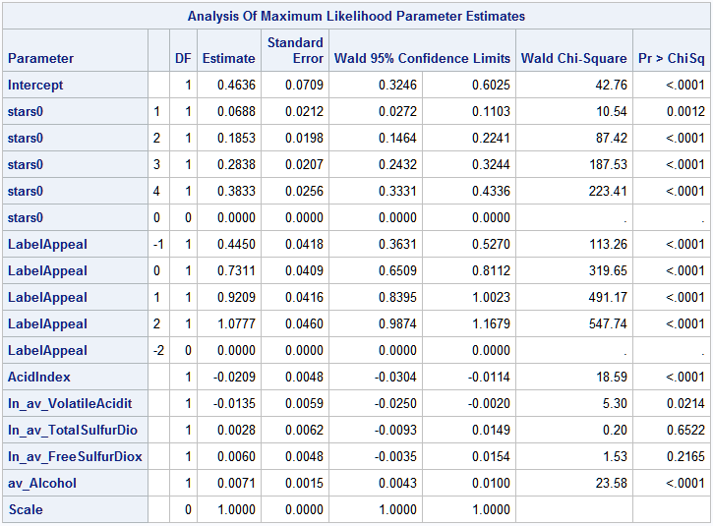

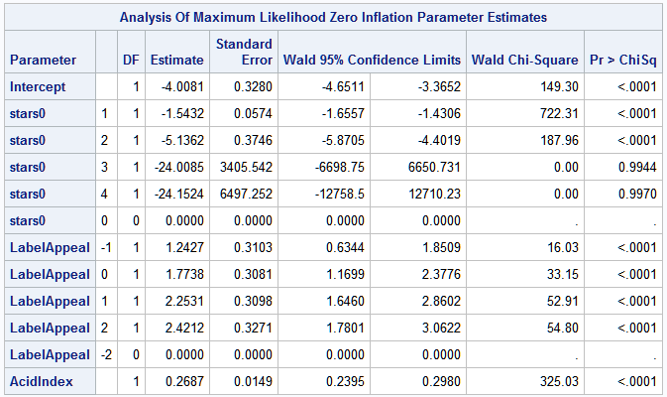

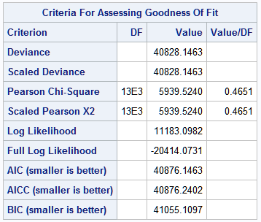

|  |  |  |  |  |
| --- | --- | --- | --- | --- |
| **Variable** | **Class** | **Estimate** | **exp(β)** | **exp(β)-1** |
| Intercept |  | -4.0081 | 0.018168 | -0.98183 |
| STARS0 | 1 | -1.5432 | 0.213696 | -0.7863 |
| STARS0 | 2 | -5.1362 | 0.00588 | -0.99412 |
| STARS0 | 3 | -24.0085 | 3.74E-11 | -1 |
| STARS0 | 4 | -24.1524 | 3.24E-11 | -1 |
| STARS0 | 0 | 0 | 1 | 0 |
| LabelAppeal | -1 | 1.2427 | 3.464956 | 2.464956 |
| LabelAppeal | 0 | 1.7738 | 5.893205 | 4.893205 |
| LabelAppeal | 1 | 2.2531 | 9.517193 | 8.517193 |
| LabelAppeal | 2 | 2.4212 | 11.25936 | 10.25936 |
| LabelAppeal | -2 | 0 | 1 | 0 |
| AcidIndex |  | 0.2687 | 1.308263 | 0.308263 |

**Model 12: GENMOD with Zero Inflated Poisson distribution (zeromodel using probit link) and STARS0 and LabelAppeal as categorical variables**

The following interpretations assume that all other variables are held constant.

* Assuming that all variables are zero (STARS0 at 0 and LabelAppeal at -2), the logarithm of the expected number of wine cases purchased would be 0.4502.
* Given that STARS0 has a base level of 0 (lowest rating), we interpret obtaining a:
  + 1 rating: 0.0608 increase in the logarithm of expected number of cases purchased
  + 2 rating: 0.1819 increase in the logarithm of expected number of cases purchased
  + 3 rating: 0.2804 increase in the logarithm of expected number of cases purchased
  + 4 rating: 0.3797 increase in the logarithm of expected number of cases purchased
* Given that LabelAppeal has a base level of -2 (lowest rating), we interpret obtaining a:
  + -1 rating: 0.4439 increase in the logarithm of expected number of cases purchased
  + 0 rating: 0.7329 increase in the logarithm of expected number of cases purchased
  + +1 rating: 0.9233 increase in the logarithm of expected number of cases purchased
  + +2 rating: 1.0807 increase in the logarithm of expected number of cases purchased
* If a wine increased its AcidIndex score by 1 point, the logarithm of expected number of wine cases purchased would be expected to decrease by 0.0189.
* If a wine increased its natural logarithm, absolute value transformed Volatile Acidity content by 1 unit, the logarithm of expected number of wine cases purchased would be expected to decrease by 0.0135.
* If a wine increased its natural logarithm, absolute value transformed Total Sulfur Dioxide content by 1 unit, the logarithm of expected number of wine cases purchased would be expected to increase by 0.0029.
* If a wine increased its natural logarithm, absolute value transformed Free Sulfur Dioxide rating by 1 unit, the logarithm of expected number of wine cases purchased would be expected to increase by 0.0060.
* If a wine increased it absolute value transformed alcohol content by 1 unit, the logarithm of expected number of wine cases purchased would be expected to increase by 0.0071.

For the zero inflated parameter estimates, assuming that all other variables are held constant:

* If all of the predictor variables in the model are evaluated at zero, the predicted probability that the number of wine cases purchased would be zero is F(-5.1960) = 1.01811E-07, where F is the cumulative distribution function of the standard normal.

However, interpretation of the coefficients in probit regression is not as straightforward as the interpretations of coefficients in linear regression or logit regression. The increase in probability attributed to a one-unit increase in a given predictor is dependent both on the values of the other predictors and the starting value of the given predictors. The probabilities do not change by a common difference or common factor.

* Given that STARS0 has a base level of 0 (lowest rating), we interpret obtaining a:
  + 1 rating: the predicted probability that the expected number of wine cases purchased will be zero decrease by a factor of 0.108397.
  + 2 rating: the predicted probability that the expected number of wine cases purchased will be zero decrease by a factor of 0.001235.
  + 3 rating: the predicted probability that the expected number of wine cases purchased will be zero decrease by a factor of 3.04e-09.
  + 4 rating: the predicted probability that the expected number of wine cases purchased will be zero decrease by a factor of 1.37e-08.
* Given that LabelAppeal has a base level of -2 (lowest rating), we interpret obtaining a:
  + -1 rating: the predicted probability that the expected number of wine cases purchased will be zero decrease by a factor of 0.807111.
  + 0 rating: the predicted probability that the expected number of wine cases purchased will be zero decrease by a factor of 0.905745.
  + +1 rating: the predicted probability that the expected number of wine cases purchased will be zero decrease by a factor of 0.958095.
  + +2 rating: the predicted probability that the expected number of wine cases purchased will be zero decrease by a factor of 0.976721.
* Increasing the AcidIndex score by 1 point decreases the predicted probability that the expected number of wine cases purchased will be zero by a factor 0.598745.

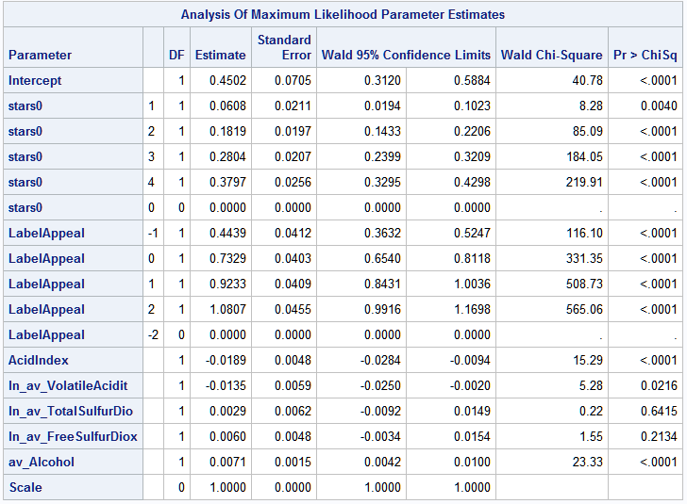

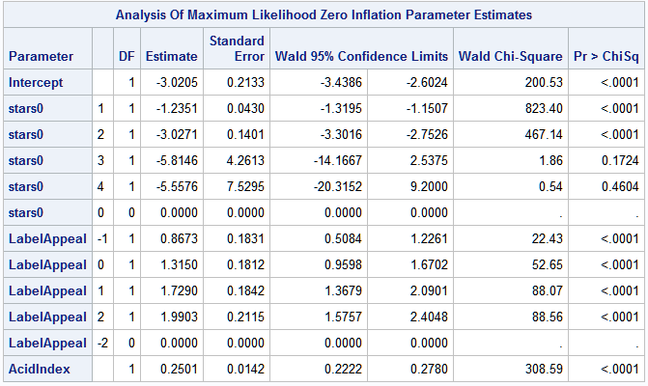

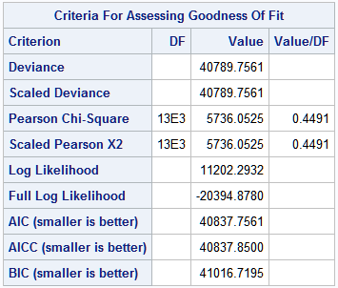

|  |  |  |  |
| --- | --- | --- | --- |
| **Variable** | **Class** | **Estimate** | **F(β)** |
| Intercept |  | -3.0205 | 0.001262 |
| STARS0 | 1 | -1.2351 | 0.108397 |
| STARS0 | 2 | -3.0271 | 0.001235 |
| STARS0 | 3 | -5.8146 | 3.04E-09 |
| STARS0 | 4 | -5.5576 | 1.37E-08 |
| STARS0 | 0 | 0 | 0.5 |
| LabelAppeal | -1 | 0.8673 | 0.807111 |
| LabelAppeal | 0 | 1.315 | 0.905745 |
| LabelAppeal | 1 | 1.729 | 0.958095 |
| LabelAppeal | 2 | 1.9903 | 0.976721 |
| LabelAppeal | -2 | 0 | 0.5 |
| AcidIndex |  | 0.2501 | 0.598745 |

It appears that model 12 actually outperforms model 6 in all metrics (lower deviance, lower log likelihood, lower AIC, lower AICC, and lower BIC). All 3 models depicted here perform very well in comparison to other 9 models. Changing the zeromodel link function does not drastically affect the model performance but in this case, it helped to generate a model that was slightly better than model 6 which I determined to be the best.

|  |  |  |  |  |  |  |  |
| --- | --- | --- | --- | --- | --- | --- | --- |
| **Model** | **Description** | **Deviance** | **Pearson**  **Chi Square** | **Log Likelihood** | **AIC** | **AICC** | **BIC** |
| **Model 6** | Zero Inflated Poisson with 2 categorical variables, zeromodel with default **logit link** | 40796.8372 | 5743.6266 | 11198.7527 | 40844.8372 | 40844.9312 | 41023.8007 |
| **Model 11** | Zero Inflated Poisson with 2 categorical variables, zeromodel with **complementary log-log link** | 40828.1463 | 5939.5240 | 11183.0982 | 40876.1463 | 40876.2402 | 41055.1097 |
| **Model 12** | Zero Inflated Poisson with 2 categorical variables, zeromodel with **probit link** | 40789.7561 | 5736.0525 | 11202.2932 | 40837.7561 | 40837.8500 | 41016.7195 |

For the first 30 observations, it appears that model 11 performs the best. The Sum of Absolute Error and Sum of Squared Error are relatively similar for all 3 models. In the future, when I am working for Zero Inflated Poisson distributions I will consider changing the zeromodel link function as it may improve performance and prediction accuracy.

|  |  |  |  |  |
| --- | --- | --- | --- | --- |
|  | **Actual Values** | **Predicted Values** | | |
| **Obs** | **TARGET** | **m6** | **m11** | **m12** |
| **1** | 3 | 3.72045 | 3.71386 | 3.72621 |
| **2** | 3 | 3.23896 | 3.24816 | 3.23529 |
| **3** | 5 | 3.36562 | 3.37015 | 3.36205 |
| **4** | 3 | 2.44195 | 2.39501 | 2.4609 |
| **5** | 4 | 3.83237 | 3.82343 | 3.83616 |
| **6** | 0 | 0.44358 | 0.39109 | 0.45738 |
| **7** | 0 | 1.2233 | 1.27962 | 1.23687 |
| **8** | 4 | 5.24074 | 5.24389 | 5.24232 |
| **9** | 3 | 2.04596 | 2.01865 | 2.00742 |
| **10** | 6 | 4.76294 | 4.76026 | 4.76286 |
| **11** | 0 | 3.99584 | 3.8912 | 3.9944 |
| **12** | 4 | 3.64193 | 3.63345 | 3.63804 |
| **13** | 3 | 4.41992 | 4.41853 | 4.4249 |
| **14** | 7 | 6.00023 | 5.99072 | 6.00276 |
| **15** | 4 | 0.89109 | 0.93571 | 0.91726 |
| **16** | 0 | 1.18559 | 1.24001 | 1.19886 |
| **17** | 0 | 0.58682 | 0.50752 | 0.60119 |
| **18** | 4 | 4.24621 | 4.24285 | 4.24695 |
| **19** | 5 | 4.28815 | 4.32823 | 4.18684 |
| **20** | 4 | 3.02866 | 3.02902 | 3.02997 |
| **21** | 3 | 2.53758 | 2.48926 | 2.55754 |
| **22** | 2 | 2.41183 | 2.36239 | 2.42842 |
| **23** | 3 | 2.74526 | 2.72721 | 2.73293 |
| **24** | 4 | 0.87861 | 0.85055 | 0.90173 |
| **25** | 4 | 3.92394 | 3.9226 | 3.92967 |
| **26** | 0 | 1.64863 | 1.63868 | 1.62426 |
| **27** | 4 | 4.50505 | 4.50401 | 4.50965 |
| **28** | 6 | 5.67084 | 5.67462 | 5.66993 |
| **29** | 4 | 4.04721 | 4.03875 | 4.05106 |
| **30** | 3 | 2.41082 | 2.36842 | 2.42196 |
| **Sum of Absolute Error** | | 29.44818 | 29.40327 | 29.55974 |
| **Sum of Squared Error** | | 54.92481 | 54.24441 | 54.85597 |

I’ve posted the SAS Data Step below for these bonus models. The resulting sas7bdat files are entitled “JoshuaPeng_testscore_zip11.sas7bdat” for the ZIP model with Cloglog link and “JoshuaPeng_testscore_zip12.sas7bdat” for the ZINB model with Probit link.

* Score test data (ZIP with Cloglog link Model 11) with SAS data step;

**data** testscore_zip11; set test0;

TEMP = **0.4636**

+ AcidIndex * -**0.0209**

+ ln_av_VolatileAcidity * -**0.0135**

+ ln_av_TotalSulfurDioxide * **0.0028**

+ ln_av_FreeSulfurDioxide * **0.0060**

+ av_Alcohol * **0.0071**

+ (stars0 in (**1**)) * **0.0688**

+ (stars0 in (**2**)) * **0.1853**

+ (stars0 in (**3**)) * **0.2838**

+ (stars0 in (**4**)) * **0.3833**

+ (LabelAppeal in (-**1**)) * **0.4450**

+ (LabelAppeal in (**0**)) * **0.7311**

+ (LabelAppeal in (**1**)) * **0.9209**

+ (LabelAppeal in (**2**)) * **1.0777**;

P_SCORE_ZIP_ALL = exp(TEMP);

TEMP = -**4.0081**

+ AcidIndex * **0.2687**

+ (stars0 in (**1**)) * -**1.5432**

+ (stars0 in (**2**)) * -**5.1362**

+ (stars0 in (**3**)) * -**24.0085**

+ (stars0 in (**4**)) * -**25.1524**

+ (LabelAppeal in (-**1**)) * **1.2427**

+ (LabelAppeal in (**0**)) * **1.7738**

+ (LabelAppeal in (**1**)) * **2.2531**

+ (LabelAppeal in (**2**)) * **2.4212**;

P_SCORE_ZERO = exp(TEMP)/(**1**+exp(TEMP));

P_TARGET_ZIP = P_SCORE_ZIP_ALL * (**1**-P_SCORE_ZERO);

keep INDEX P_TARGET_ZIP;

**run**;

* Score test data (ZIP with Probit link Model 12) with SAS data step;

**data** testscore_zip12; set test0;

TEMP = **0.4502**

+ AcidIndex * -**0.0189**

+ ln_av_VolatileAcidity * -**0.0135**

+ ln_av_TotalSulfurDioxide * **0.0029**

+ ln_av_FreeSulfurDioxide * **0.0060**

+ av_Alcohol * **0.0071**

+ (stars0 in (**1**)) * **0.0608**

+ (stars0 in (**2**)) * **0.1819**

+ (stars0 in (**3**)) * **0.2804**

+ (stars0 in (**4**)) * **0.3797**

+ (LabelAppeal in (-**1**)) * **0.4439**

+ (LabelAppeal in (**0**)) * **0.7329**

+ (LabelAppeal in (**1**)) * **0.9233**

+ (LabelAppeal in (**2**)) * **1.0807**;

P_SCORE_ZIP_ALL = exp(TEMP);

TEMP = -**3.0205**

+ AcidIndex * **0.2501**

+ (stars0 in (**1**)) * -**1.2351**

+ (stars0 in (**2**)) * -**3.0271**

+ (stars0 in (**3**)) * -**5.8146**

+ (stars0 in (**4**)) * -**5.5576**

+ (LabelAppeal in (-**1**)) * **0.8673**

+ (LabelAppeal in (**0**)) * **1.3150**

+ (LabelAppeal in (**1**)) * **1.7290**

+ (LabelAppeal in (**2**)) * **1.9903**;

P_SCORE_ZERO = exp(TEMP)/(**1**+exp(TEMP));

P_TARGET_ZIP = P_SCORE_ZIP_ALL * (**1**-P_SCORE_ZERO);

keep INDEX P_TARGET_ZIP;

**run**;

**Comparing PROC PLM vs. SAS Data Step for Zero Inflated Poisson/Negative Binomial models**

The Zero Inflated Poisson (ZIP) model (and also the Zero Inflated Negative Binomial (ZINB) model) are composed of 2 model processes. Because of this important point, I cannot generate the same, correct predicted values using PROC PLM on the PROC GENMOD stored output file as with a SAS data step. I have to write a separate SAS data step to obtain the correct predicted target values. The following are the SAS data steps to generate my ZIP and ZINB models. The following is my SAS code to compare the PROC PLM and SAS data step predicted value output of my best ZIP and ZINB models.

* Loading in data;

**data** train; set wine;

**data** test; set wine_test;

* Imputing missing observations with mean value and adding new variables in training set;

**data** train0; set train;

if missing(Alcohol) then alcohol = **10.4892363**;

if missing(FreeSulfurDioxide) then FreeSulfurDioxide = **30.8455713**;

stars0 = stars;

if missing(stars) then stars0 = **0**;

if missing(TotalSulfurDioxide) then TotalSulfurDioxide = **120.7142326**;

av_Alcohol = abs(Alcohol);

av_VolatileAcidity = abs(VolatileAcidity);

av_FreeSulfurDioxide = abs(FreeSulfurDioxide);

av_TotalSulfurDioxide = abs(TotalSulfurDioxide);

if av_VolatileAcidity = **0** then ln_av_VolatileAcidity = **0**;

else ln_av_VolatileAcidity = log(av_VolatileAcidity);

if av_FreeSulfurDioxide = **0** then ln_av_FreeSulfurDioxide = **0**;

else ln_av_FreeSulfurDioxide = log(av_FreeSulfurDioxide);

if av_TotalSulfurDioxide = **0** then ln_av_TotalSulfurDioxide = **0**;

else ln_av_TotalSulfurDioxide = log(av_TotalSulfurDioxide);

* Variable of reference: 0;

if STARS0 in (**0** **1** **2** **3** **4**) then do;

STARS0_1 = (STARS0 eq **1**);

STARS0_2 = (STARS0 eq **2**);

STARS0_3 = (STARS0 eq **3**);

STARS0_4 = (STARS0 eq **4**);

end;

* Variable of reference: -2;

if LabelAppeal in (-**2** -**1** **0** **1** **2**) then do;

LabelAppeal_n1 = (LabelAppeal eq -**1**);

LabelAppeal_0 = (LabelAppeal eq **0**);

LabelAppeal_p1 = (LabelAppeal eq **1**);

LabelAppeal_p2 = (LabelAppeal eq **2**);

end;

**run**;

* Imputing missing observations with mean value and adding new variables in test set;

**data** test0; set test;

if missing(Alcohol) then alcohol = **10.4892363**;

if missing(FreeSulfurDioxide) then FreeSulfurDioxide = **30.8455713**;

stars0 = stars;

if missing(stars) then stars0 = **0**;

if missing(TotalSulfurDioxide) then TotalSulfurDioxide = **120.7142326**;

av_Alcohol = abs(Alcohol);

av_VolatileAcidity = abs(VolatileAcidity);

av_FreeSulfurDioxide = abs(FreeSulfurDioxide);

av_TotalSulfurDioxide = abs(TotalSulfurDioxide);

if av_VolatileAcidity = **0** then ln_av_VolatileAcidity = **0**;

else ln_av_VolatileAcidity = log(av_VolatileAcidity);

if av_FreeSulfurDioxide = **0** then ln_av_FreeSulfurDioxide = **0**;

else ln_av_FreeSulfurDioxide = log(av_FreeSulfurDioxide);

if av_TotalSulfurDioxide = **0** then ln_av_TotalSulfurDioxide = **0**;

else ln_av_TotalSulfurDioxide = log(av_TotalSulfurDioxide);

* Variable of reference: 0;

if STARS0 in (**0** **1** **2** **3** **4**) then do;

STARS0_1 = (STARS0 eq **1**);

STARS0_2 = (STARS0 eq **2**);

STARS0_3 = (STARS0 eq **3**);

STARS0_4 = (STARS0 eq **4**);

end;

* Variable of reference: -2;

if LabelAppeal in (-**2** -**1** **0** **1** **2**) then do;

LabelAppeal_n1 = (LabelAppeal eq -**1**);

LabelAppeal_0 = (LabelAppeal eq **0**);

LabelAppeal_p1 = (LabelAppeal eq **1**);

LabelAppeal_p2 = (LabelAppeal eq **2**);

end;

**run**;

* Generating GENMOD ZIP model and storing output file as m6;

**proc** **genmod** data=train0;

class stars0 (ref="0") labelappeal (ref="-2");

model target = stars0 labelappeal acidindex ln_av_volatileacidity ln_av_totalsulfurdioxide

ln_av_freesulfurdioxide av_alcohol / link=log dist=zip;

zeromodel stars0 labelappeal acidindex / link=logit;

store out=m6;

**run**;

* Scoring ZIP test data with PROC PLM;

**proc** **plm** source=m6;

score data=test0 out=testscore_zip0 pred=p_1 / ilink;

**run**;

* Generating GENMOD ZINB model and storing output file as m8;

**proc** **genmod** data=train0;

class stars0 (ref="0") labelappeal (ref="-2");

model target = stars0 labelappeal acidindex ln_av_volatileacidity ln_av_totalsulfurdioxide

ln_av_freesulfurdioxide av_alcohol / link=log dist=zinb;

zeromodel stars0 labelappeal acidindex / link=logit;

store out=m8;

**run**;

* Scoring ZINB test data with PROC PLM;

**proc** **plm** source=m8;

score data=test0 out=testscore_zinb0 pred=p_1 / ilink;

**run**;

* Keeping only INDEX and P_TARGET_ZIP;

**data** testscore_zip0; set testscore_zip0;

P_TARGET_ZIP = p_1;

keep INDEX P_TARGET_ZIP;

**run**;

* Keeping only INDEX and P_TARGET_ZINB;

**data** testscore_zinb0; set testscore_zinb0;

P_TARGET_ZINB = p_1;

keep INDEX P_TARGET_ZINB;

**run**;

* Score test data (ZIP Model 6) with SAS data step;

**data** testscore_zip; set test0;

TEMP = **0.4532**

+ AcidIndex * -**0.0632**

+ ln_av_VolatileAcidity * -**0.0135**

+ ln_av_TotalSulfurDioxide * **0.0028**

+ ln_av_FreeSulfurDioxide * **0.0059**

+ av_Alcohol * **0.0071**

+ (stars0 in (**1**)) * **0.0632**

+ (stars0 in (**2**)) * **0.1834**

+ (stars0 in (**3**)) * **0.2816**

+ (stars0 in (**4**)) * **0.3809**

+ (LabelAppeal in (-**1**)) * **0.4432**

+ (LabelAppeal in (**0**)) * **0.7311**

+ (LabelAppeal in (**1**)) * **0.9213**

+ (LabelAppeal in (**2**)) * **1.0785**;

P_SCORE_ZIP_ALL = exp(TEMP);

TEMP = -**5.1960**

+ AcidIndex * **0.4322**

+ (stars0 in (**1**)) * -**2.0682**

+ (stars0 in (**2**)) * -**5.8044**

+ (stars0 in (**3**)) * -**24.9701**

+ (stars0 in (**4**)) * -**25.1438**

+ (LabelAppeal in (-**1**)) * **1.4799**

+ (LabelAppeal in (**0**)) * **2.2270**

+ (LabelAppeal in (**1**)) * **2.9280**

+ (LabelAppeal in (**2**)) * **3.3765**;

P_SCORE_ZERO = exp(TEMP)/(**1**+exp(TEMP));

P_TARGET_ZIP = P_SCORE_ZIP_ALL * (**1**-P_SCORE_ZERO);

keep INDEX P_TARGET_ZIP;

**run**;

* Score test data (ZINB Model 8) with SAS data step;

**data** testscore_zinb; set test0;

TEMP = **0.4532**

+ AcidIndex * -**0.0632**

+ ln_av_VolatileAcidity * -**0.0135**

+ ln_av_TotalSulfurDioxide * **0.0028**

+ ln_av_FreeSulfurDioxide * **0.0059**

+ av_Alcohol * **0.0071**

+ (stars0 in (**1**)) * **0.0632**

+ (stars0 in (**2**)) * **0.1834**

+ (stars0 in (**3**)) * **0.2816**

+ (stars0 in (**4**)) * **0.3809**

+ (LabelAppeal in (-**1**)) * **0.4432**

+ (LabelAppeal in (**0**)) * **0.7311**

+ (LabelAppeal in (**1**)) * **0.9213**

+ (LabelAppeal in (**2**)) * **1.0785**;

P_SCORE_ZINB_ALL = exp(TEMP);

TEMP = -**5.1960**

+ AcidIndex * **0.4322**

+ (stars0 in (**1**)) * -**2.0682**

+ (stars0 in (**2**)) * -**5.8044**

+ (stars0 in (**3**)) * -**24.9701**

+ (stars0 in (**4**)) * -**25.1438**

+ (LabelAppeal in (-**1**)) * **1.4799**

+ (LabelAppeal in (**0**)) * **2.2270**

+ (LabelAppeal in (**1**)) * **2.9280**

+ (LabelAppeal in (**2**)) * **3.3765**;

P_SCORE_ZERO = exp(TEMP)/(**1**+exp(TEMP));

P_TARGET_ZINB = P_SCORE_ZINB_ALL * (**1**-P_SCORE_ZERO);

keep INDEX P_TARGET_ZINB;

**run**;

As you can see, the first 37 observations are different when using a SAS data step vs. PROC PLM.

|  |  |
| --- | --- |
| ZIP model predicted values using SAS data step | ZIP model predicted values using PROC PLM |
|  |  |

|  |  |
| --- | --- |
| ZINB model predicted values using SAS data step | ZINB model predicted values using PROC PLM |
|  |  |

The full SAS code to compare PROC PLM and the SAS Data Step along with the SAS Data Steps for generating predicted values for the ZIP models with Cloglog link and Probit link are fully included in “Joshua Peng Deploy Model Bonus.sas.”

# 7. Conclusion

The purpose of this assignment was to develop a model to predict the number of cases of wine that will be sold given certain properties of the wine. The wine training data set contained 12,795 observations and 14 variables. Two of the variables were subjective variables which I utilized as both quantitative and categorical variables during the modeling process. There were 12 continuous variables related to the chemical properties of the wine being sold. There were 2 numerical variables for the marketing score based on the visual appeal of the label and wine rating based on number of stars. The target variable is the number of sample cases of wine that were purchased by wine distribution companies after sampling a wine. The purpose of this project was to build a model to predict the number of cases of wine that will be sold given certain properties of the wine. I first examined all of the variables and found that many had negative values which should not be possible since these variables measure the physical amount or level of a substance (count variables). For variables with negative values, I added reshifted (adding the absolute value of the minimum negative value) variables and the absolute value transformed counterparts. I also computed BoundSulfurDioxide from TotalSulfurDioxide and FreeSulfurDioxide and TotalAcidity from VolatileAcidity and FixedAcidity. For variables with missing observations, I imputed missing observations with the mean value. I added STARS0 which was the same as STARS but had the missing observations in its own class equal to zero. I generated the correlation table with TARGET and ran automatic variable selection methods with PROC HPGENSELECT in order to narrow down my set of variables to the 7 best variables. I built several Poisson and Negative Binomial distribution models with and without the zero inflation model to predict the target number of cases ordered for each wine. I also built a linear regression model to compare with all of the other models. I compared 12 models of 7 variables each and found that the best model was a Zero Inflated Poisson distribution model with the STARS0 and LabelAppeal variables used as categorical variables.

I believe this data set could be improved with a wine type variable. All of the physical characteristics such as density, sulfite content, acidity, chlorides, residual sugar, pH, and alcohol all vary with wine type, whether it is a red wine, white wine, rosé wine, dry white wine, dry red wine, sweet white wine, sweet red wine, sherry grape wines, etc. Even consumers have preferences for different wines, and their personal affinity for a certain type of wine will influence and affect their wine rating (STARS). It would be interesting to see the differences in physical characteristics between red and white wines and determine which type of wine is most preferred among the two major types. Other variables that would also be interesting to look at would be wine age, country of origin, and color density.

# 8. References

1. Sulphur in the winery. 2016; <http://www.morethanorganic.com/sulphur-in-the-winery>. Accessed February 17, 2016.

2. Carel M. Sulfur Dioxide (SO2) in wine | Wine From Here. 2011; <http://winobrothers.com/2011/10/11/sulfur-dioxide-so2-in-wine/>. Accessed February 17, 2016.

3. Grubbs S. Wine Jargon: What is Residual Sugar? | Serious Eats. 2013; <http://drinks.seriouseats.com/2013/04/wine-jargon-what-is-residual-sugar-riesling-fermentation-steven-grubbs.html>. Accessed February 17, 2016.

4. Pandell AJ. The Acidity of Wine. 2011; <http://www.wineperspective.com/the_acidity_of_wine.htm>. Accessed February 17, 2016.

5. Nierman D. Fixed Acidity — Waterhouse Lab. 2014; <http://waterhouse.ucdavis.edu/whats-in-wine/fixed-acidity>. Accessed February 17, 2016.

6. Neeley E. Volatile Acidity — Waterhouse Lab. 2004; <http://waterhouse.ucdavis.edu/whats-in-wine/volatile-acidity>. Accessed February 17, 2016.

7. Leonardelli MJ. Acidity in Wine: The importance of management through measurement. 2013(February 17, 2016). <http://gwi.missouri.edu/publications/2013spring.pdf>.

8. Colby C. Calibrate your Winemaking Tools - WineMaker Magazine. 2008; <https://winemakermag.com/127-calibrate-your-winemaking-tools>. Accessed February 17, 2016.

9. Henrie J. Taking the Fear Out of Must Analysis - WineMaker Magazine. 1999; <https://winemakermag.com/654-taking-the-fear-out-of-must-analysis>. Accessed February 17, 2016.

10. Citric Acid | Viticulture & Enology. 2014; <http://wineserver.ucdavis.edu/industry/enology/methods_and_techniques/reagents/citric_acid.html>. Accessed February 17, 2016.

11. Coli MS, Rangel AGP, Souza ES, Oliveira MF, Chiaradia ACN. Chloride concentration in red wines: influence of terroir and grape type. *Food Science and Technology (Campinas).* 2015;35:95-99.

12. A Guide to the Alcohol Content in Wine - Real Simple. 2016; <http://www.realsimple.com/holidays-entertaining/entertaining/food-drink/alcohol-content-wine>. Accessed February 17, 2016.

13. Taylor R. The Truth About Grape Growing and Wine Making. 2013.